Analysis of BMJ submission data over time. Are there more papers and reviews submitted on weekends, holidays and late nights?

Adrian Barnett

04 November 2019

# Modelling approach

All statistical models were fitted using a Bayesian approach and therefore show 95% credible intervals instead of confidence intervals. Credible intervals have the more intuitive interpretation of having a 95% probability of containing the true estimate. We do not use p-values.

When describing changes over time we sometimes use the word “slope”.

# Flow diagrams of data

The diagrams below show what journal submissions and reviews were included in the final analyses.

## Diagram for submissions

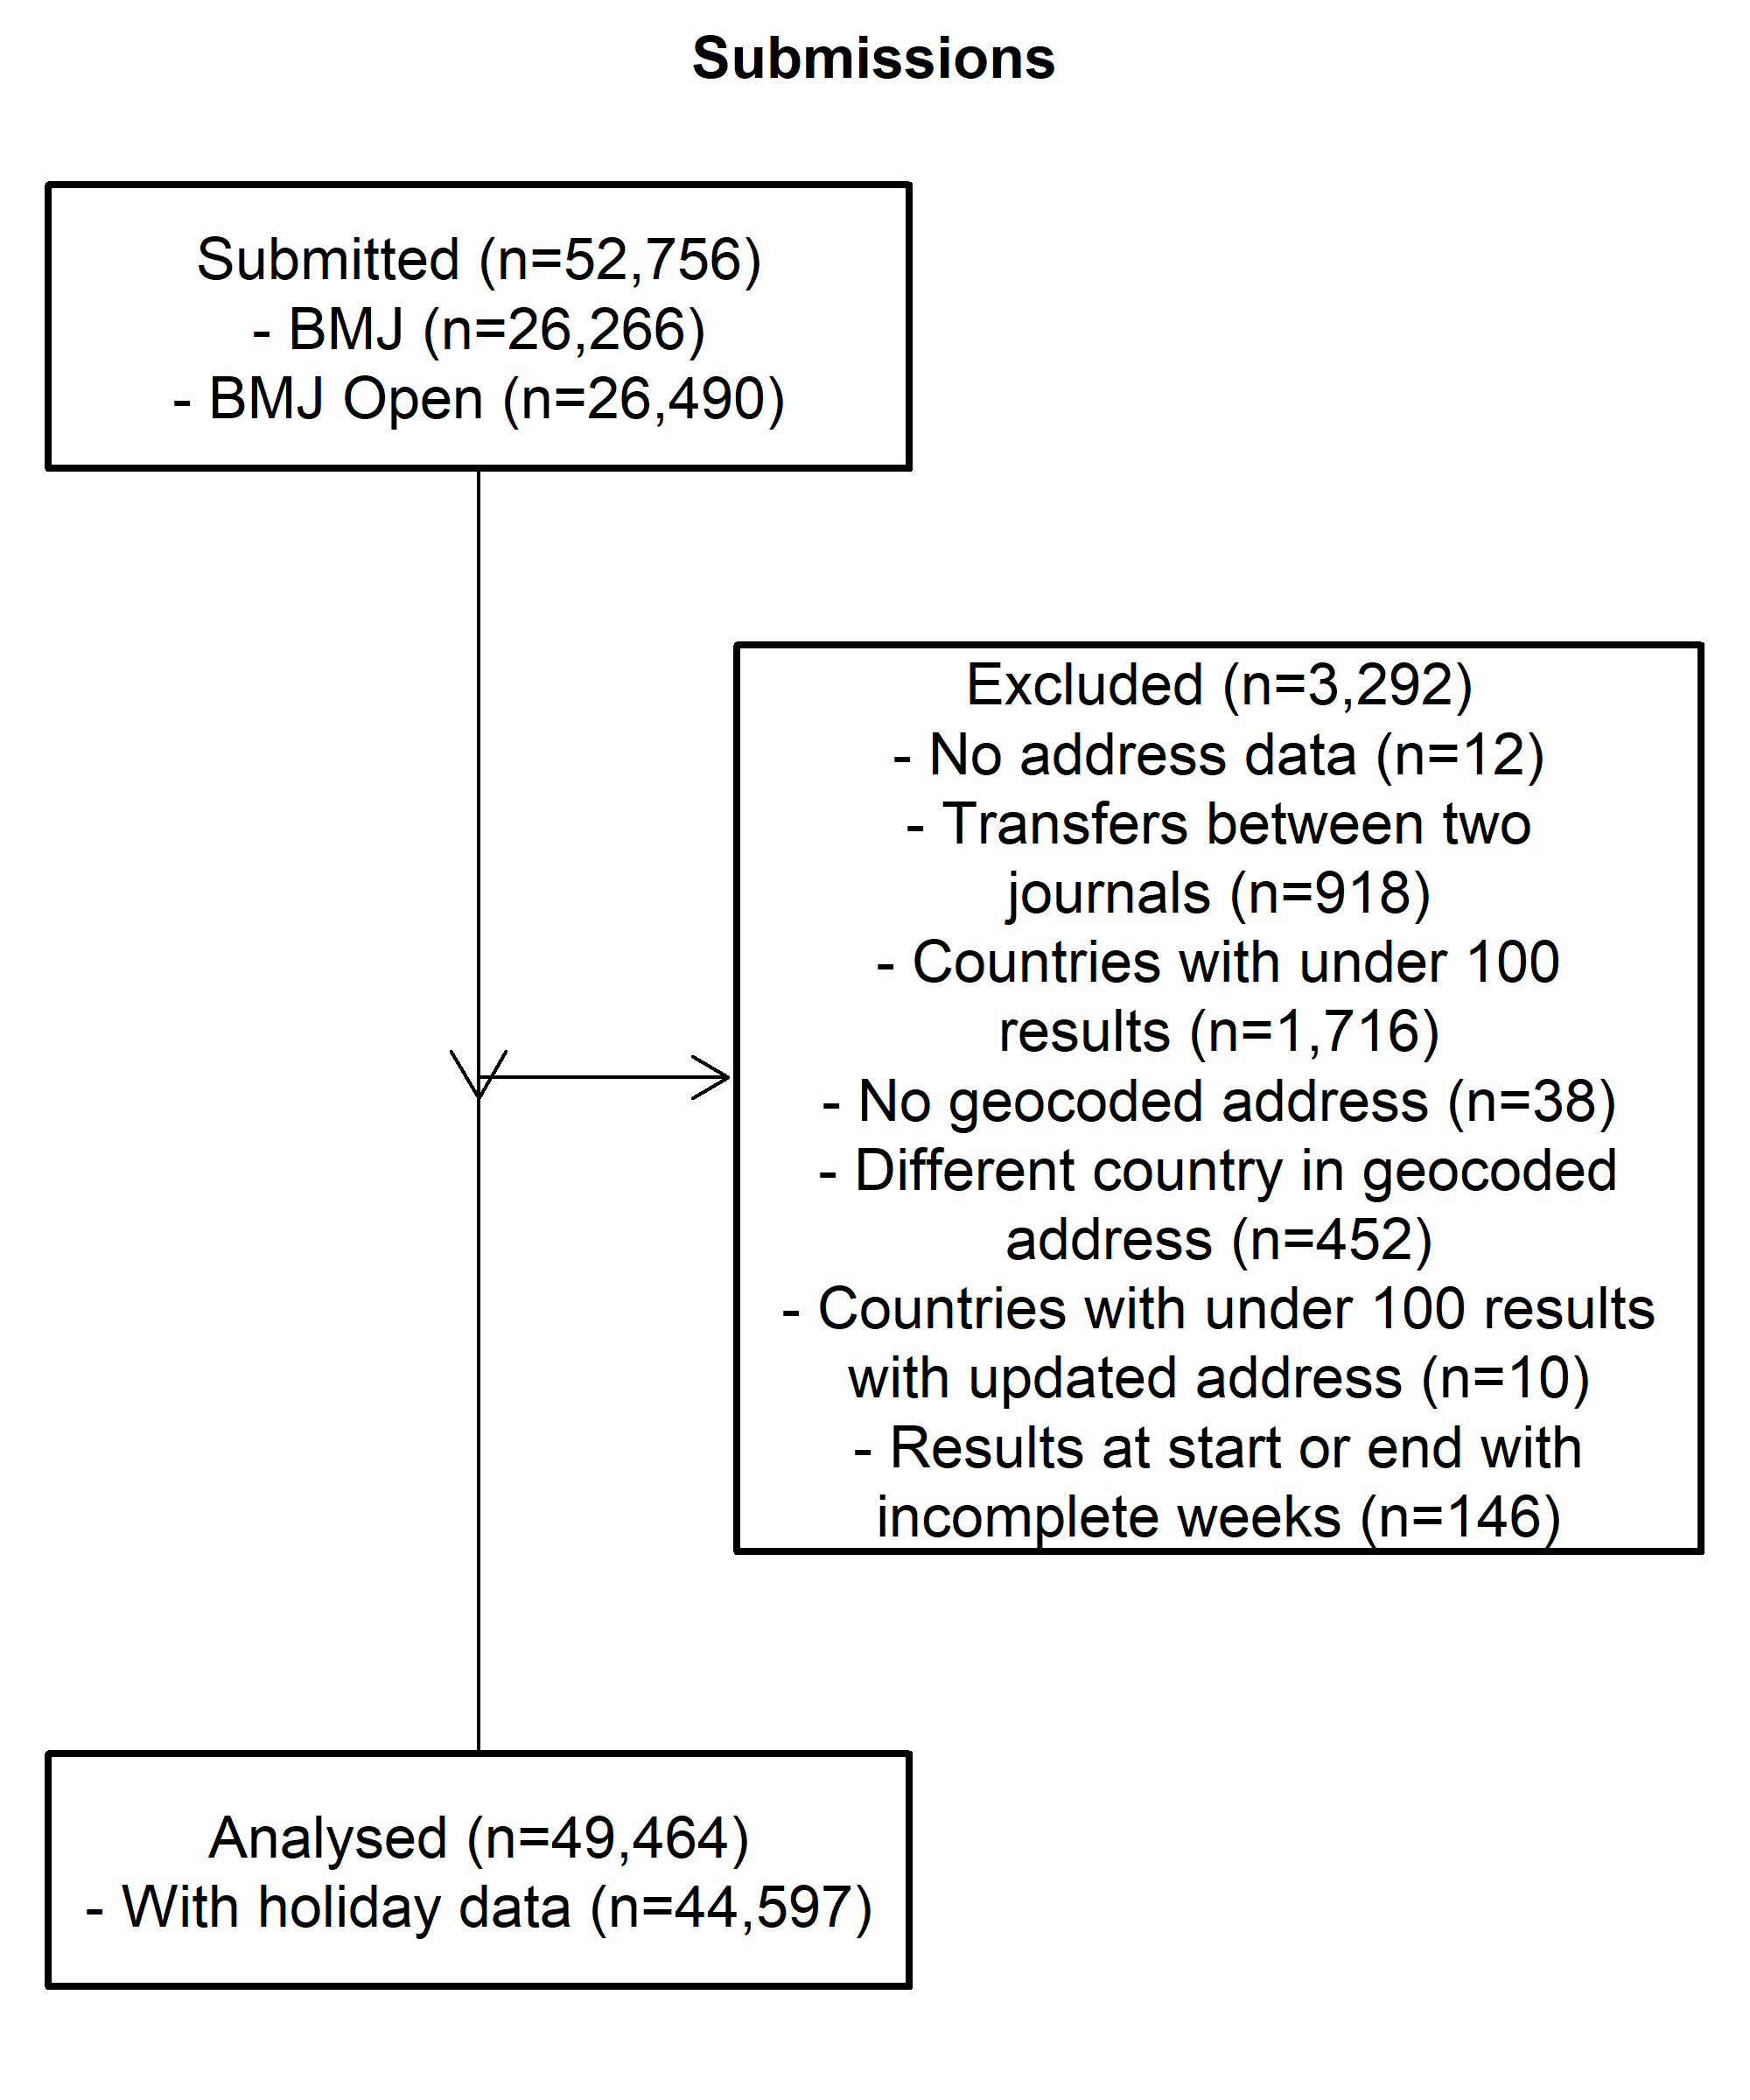

## Diagram for reviews

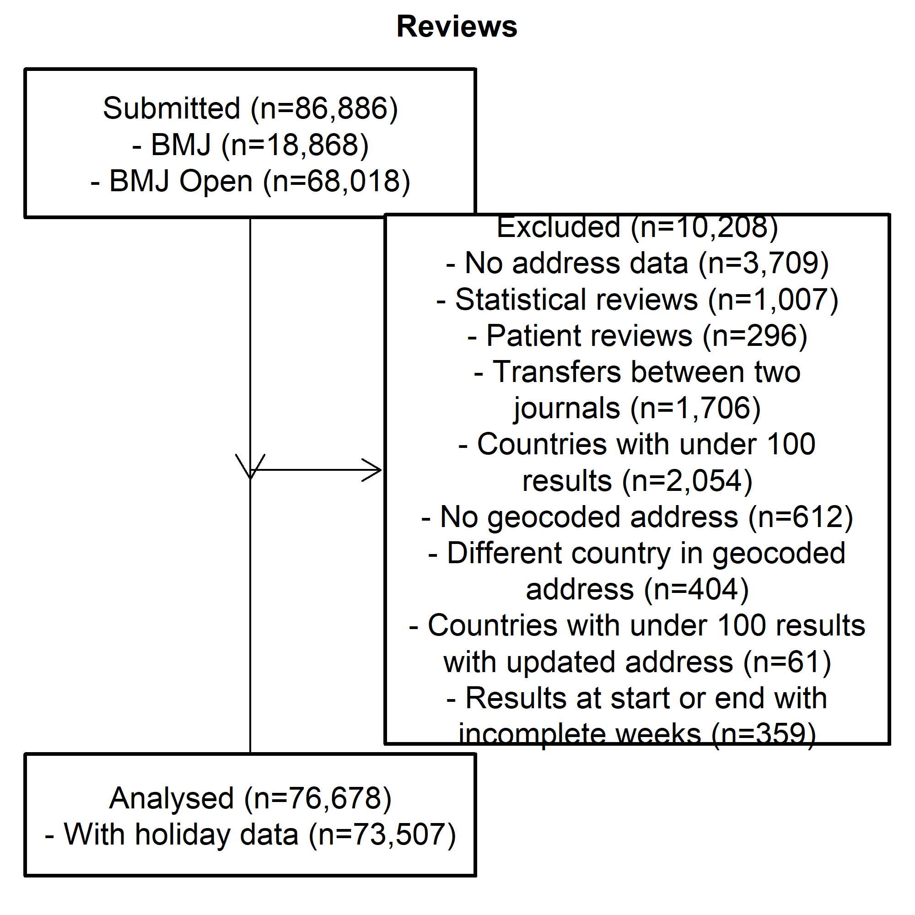

# Summary data on numbers

## Journal numbers

The data are from the journals *BMJ* and *BMJ Open*.

|  |  |  |  |  |
| --- | --- | --- | --- | --- |
| Type | Journal n | Percent | All n | Percent |
| *Reviews* | 76678 | 100 | 76678 | 100 |
| *Submission* | 49464 | 100 | 49464 | 100 |

## Journal submissions and reviews over time

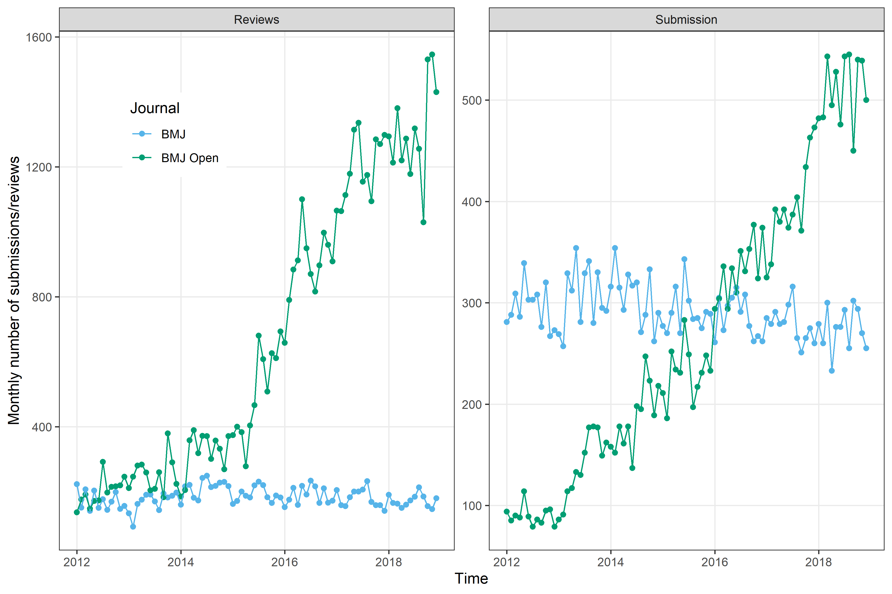

The plot shows the number of submissions and reviews over time for the two journals. There has been a clear increase in monthly submissions for *BMJ Open* with a mirrored increase in review numbers, although on a much larger scale.

This plot is potentially commercial-in-confidence and we should check if *BMJ* are happy for it to appear in reports.

# Times of day

Here we examine the time-of-day pattern of submissions and reviews by weekdays vs weekends. Using all the countries created plots that were too busy, hence we only show the top ten countries.

The percents are by country and weekday/weekend, so the percents add to 100% for each country on weekdays, and also add to 100% on weekends.

## Star plots of submissions by hour of day for top ten countries

The star plots show the percentages of submissions made in each country and also split by the weekday and weekend. The aim is to see what times of the day researchers are most active and if there are noticeable differences between countries.

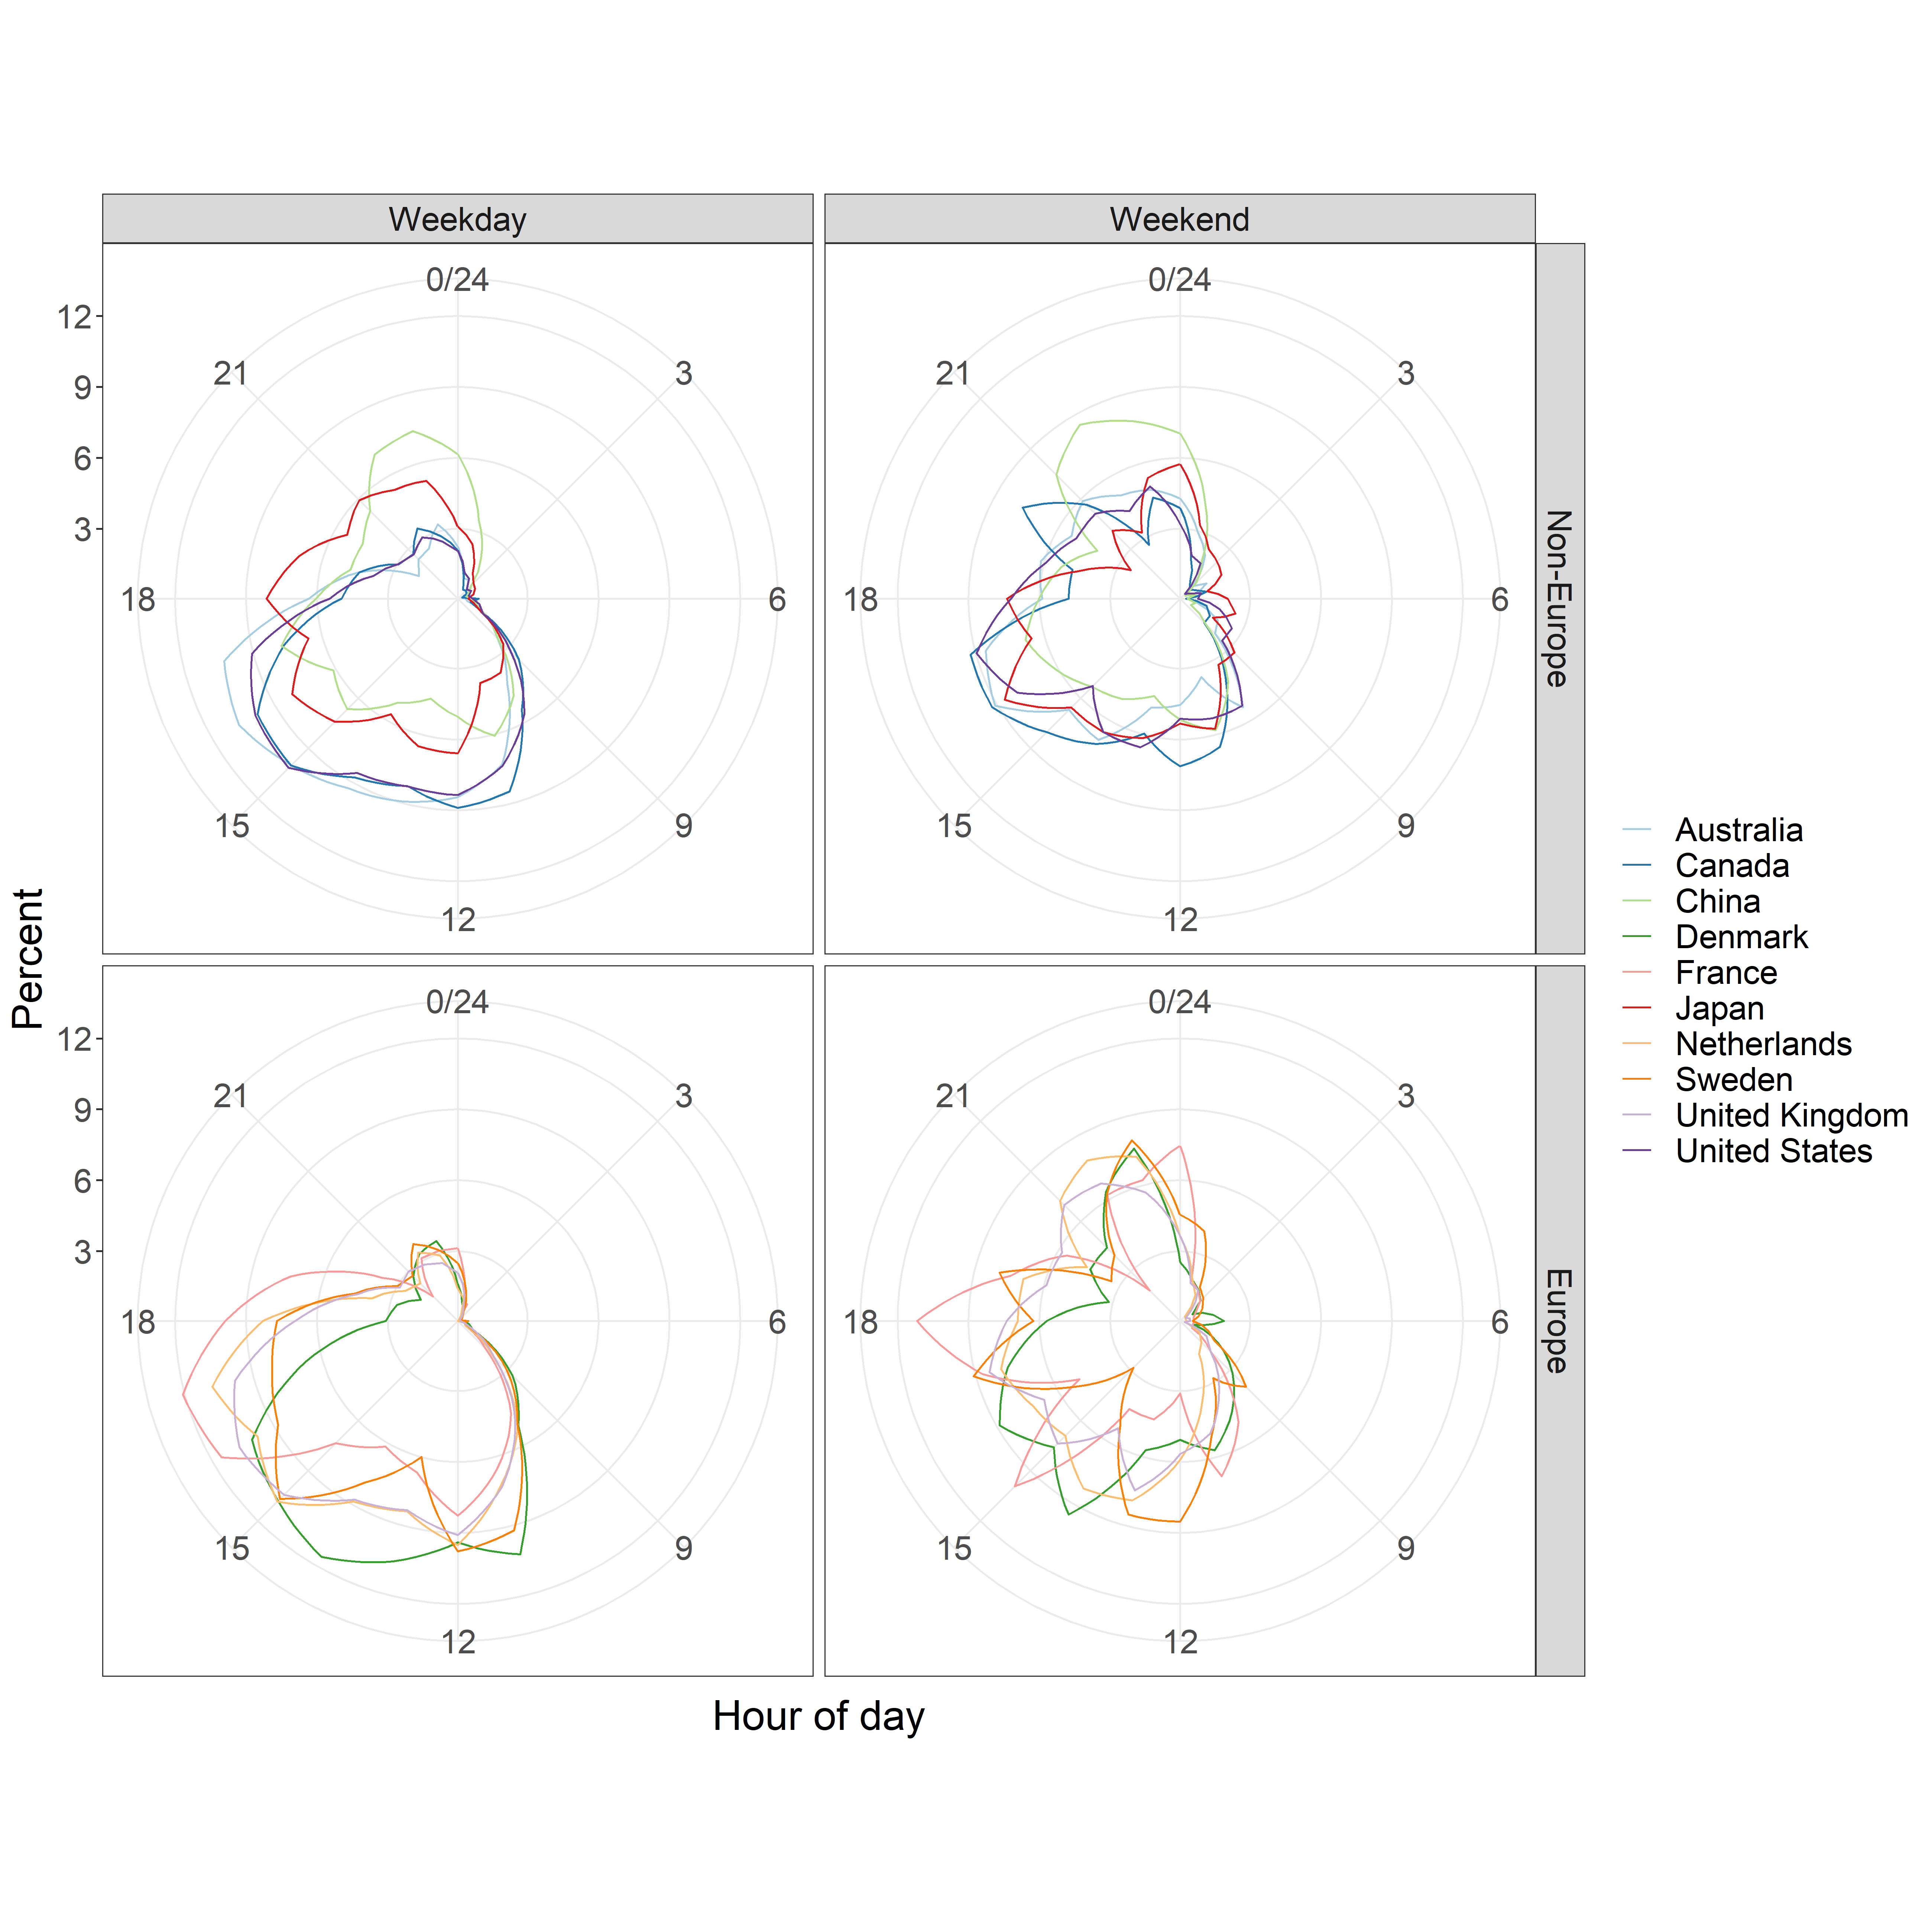

The lines are smoother on weekdays because of the larger sample size.

### Line plots of submission times

This plot shows the same information as the star plot, but using a linear time axis.

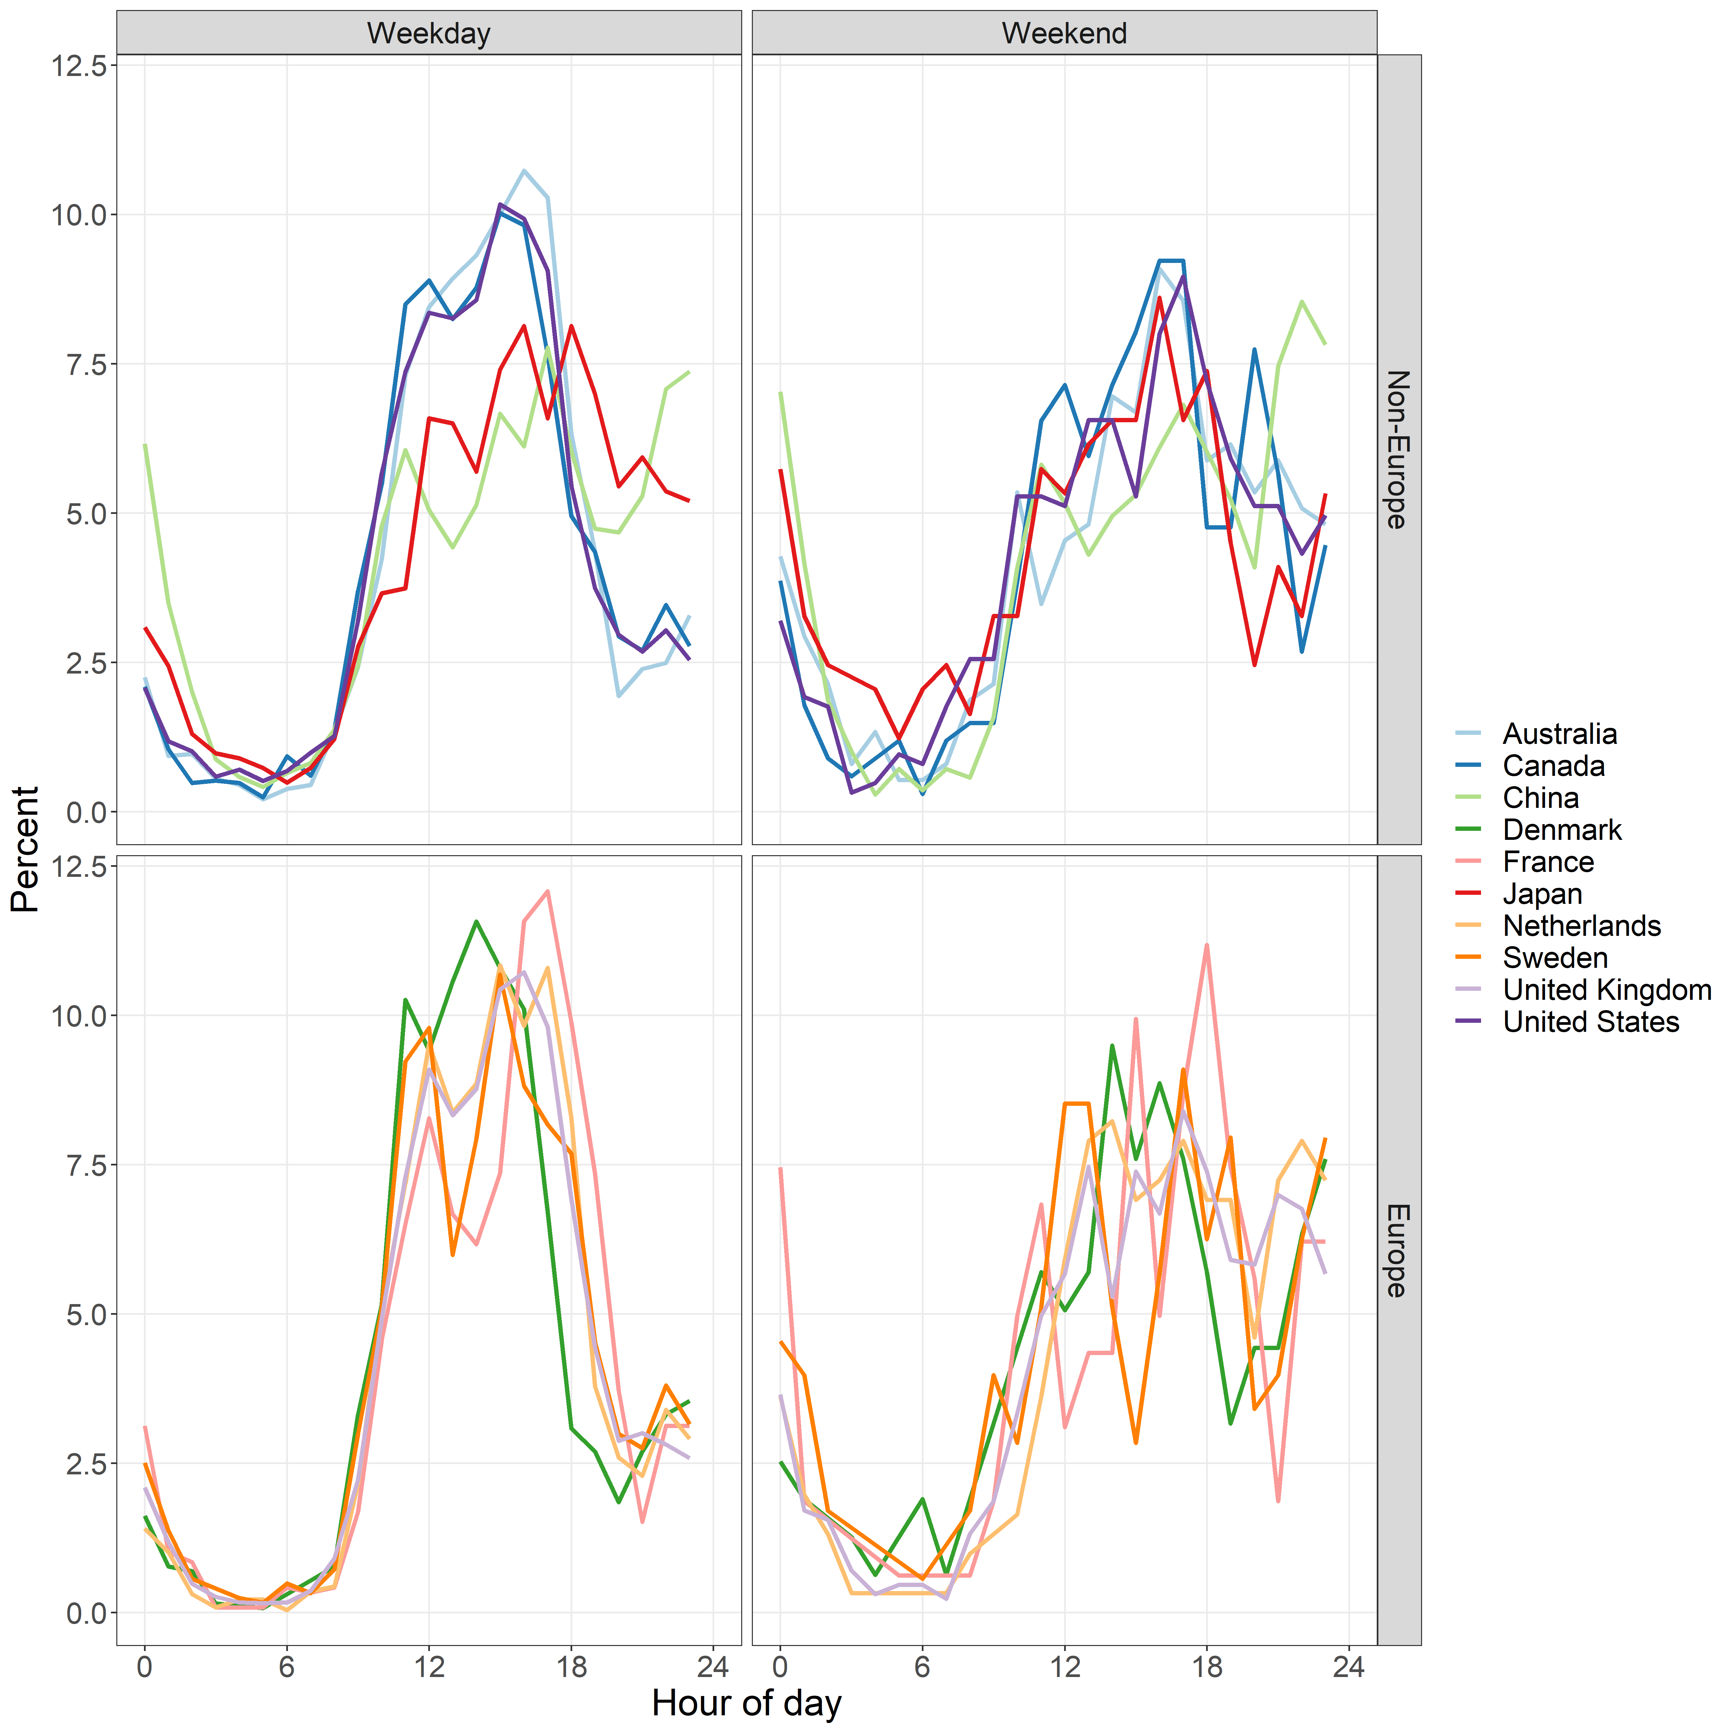

As well as the obvious diurnal pattern, there does appear to be a slight increase in submissions just before midnight.

## Star plots of reviews by hour of day for top ten countries

The star plots show the percentages of reviews made in each country and also split by the weekday and weekend.

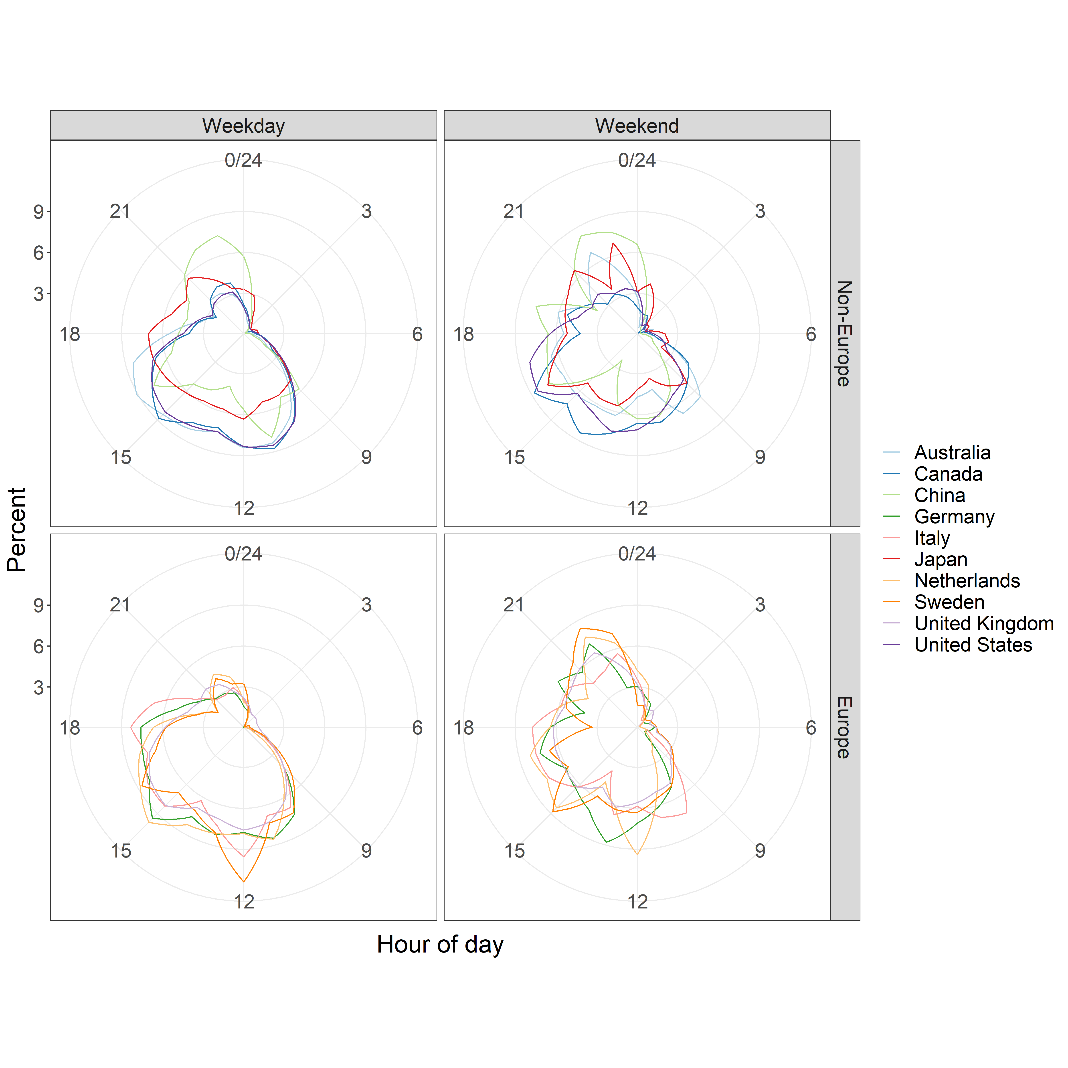

### Line plots of review times

This plot shows the same information as the star plot, but using a linear time axis.

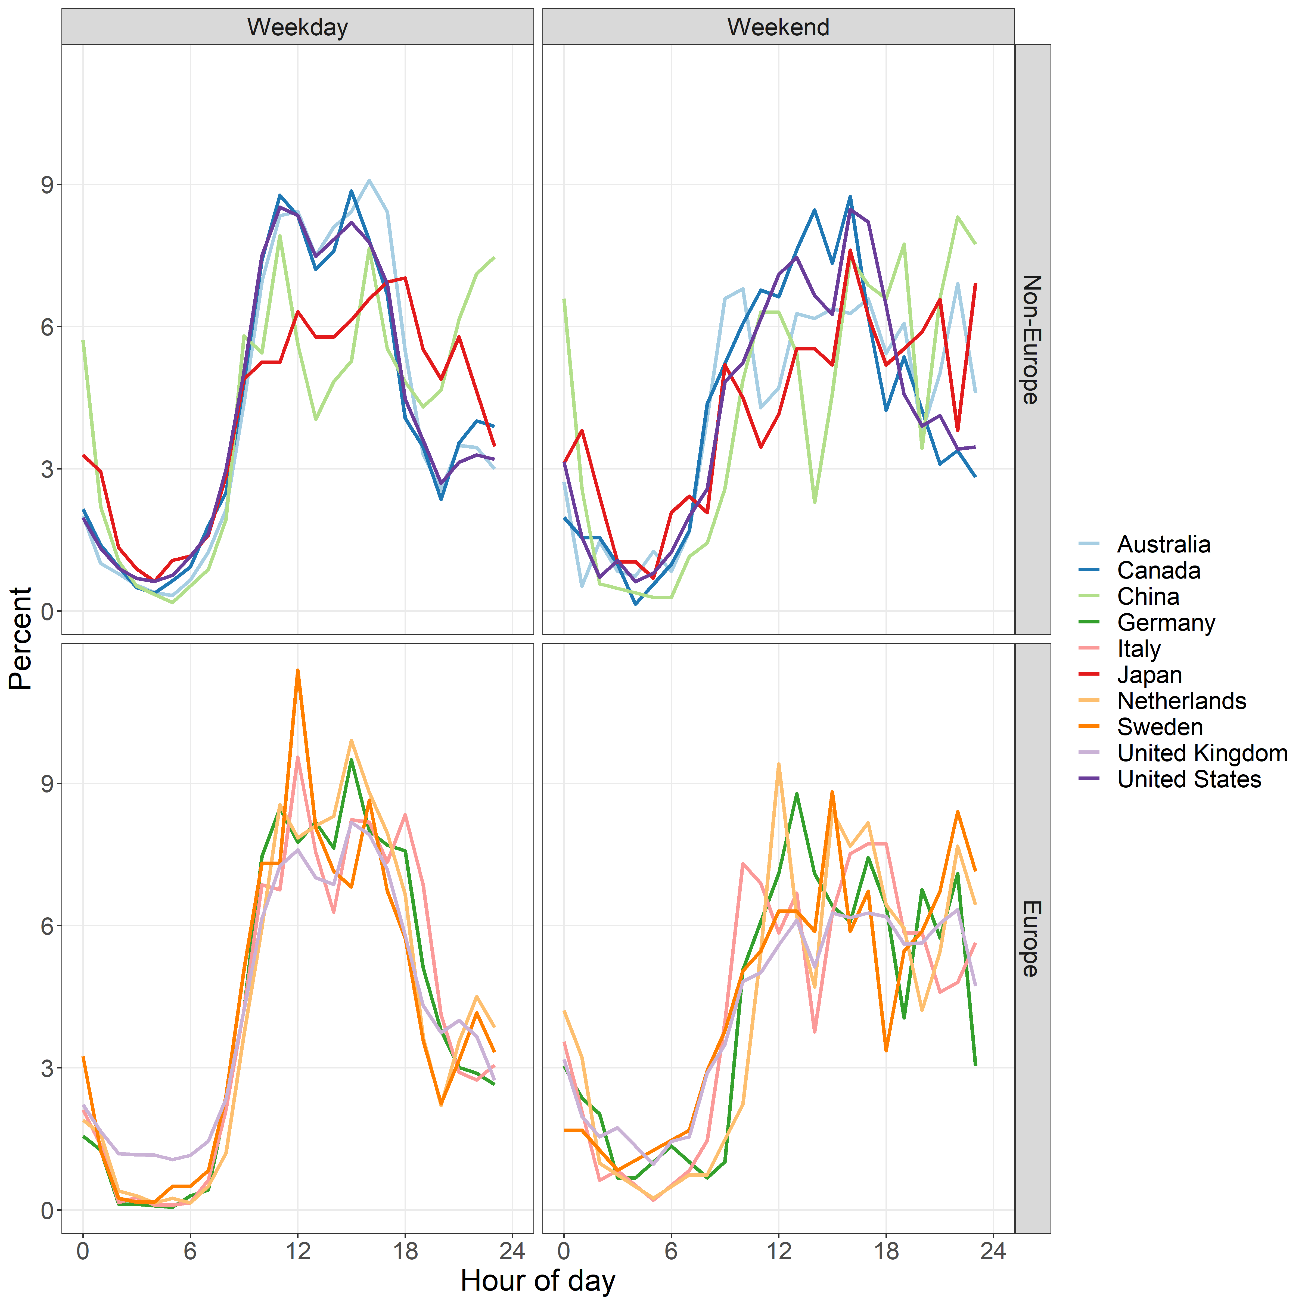

As well as the obvious diurnal pattern, there may be small lunch time peaks in some countries.

## Line plots of the ratio of submissions to reviews by hour of day for the top ten countries

The plot below shows the ratio of the percentage of submissions to reviews, so it combines the data from the above line plots. The aim is to show times when relatively more submissions are received than reviews. The plot uses percents and not absolute numbers, so it looks at the relative difference in activity. There are far more reviews than submissions, so if we used absolute numbers any relative change would be lost.

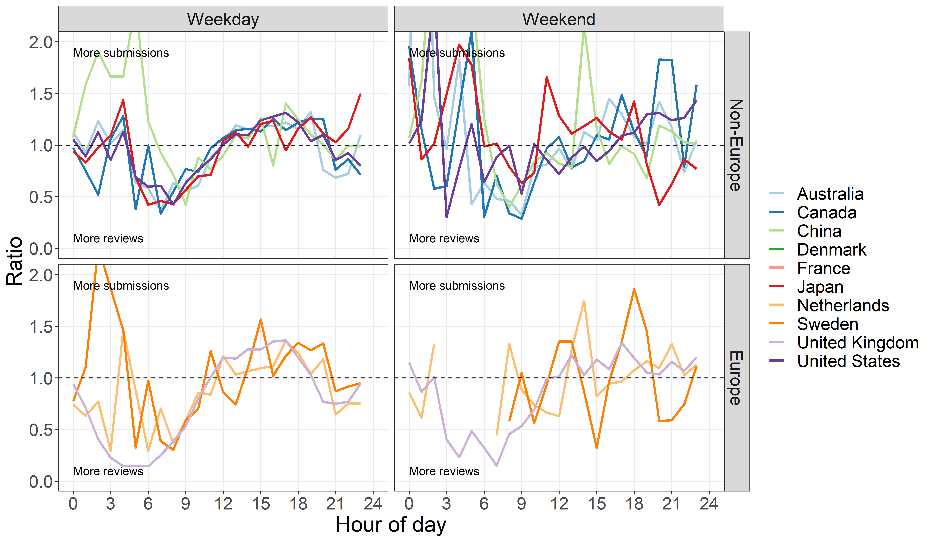

The percent axis has been truncated as there were a few very large estimates in early mornings on weekends, but these had small sample sizes.

# Weekends

In this section we tabulate, plot and model the data on weekend submissions and reviews.

## Submissions

The table shows the overall frequency of submissions on weekdays and weekends in the top ten submitting countries.

|  |  |  |  |  |
| --- | --- | --- | --- | --- |
| Country | Weekday n | % | Weekend n | % |
| *Australia* | 2889 | 88.5 | 374 | 11.5 |
| *Canada* | 2485 | 88.1 | 336 | 11.9 |
| *China* | 4789 | 77.5 | 1394 | 22.5 |
| *Denmark* | 1297 | 89.1 | 158 | 10.9 |
| *France* | 1184 | 88.0 | 161 | 12.0 |
| *Japan* | 1230 | 83.4 | 244 | 16.6 |
| *Netherlands* | 2270 | 88.2 | 304 | 11.8 |
| *Sweden* | 1236 | 87.5 | 176 | 12.5 |
| *United Kingdom* | 10161 | 88.8 | 1287 | 11.2 |
| *United States* | 4250 | 87.2 | 625 | 12.8 |
| *All* | 31791 | 86.3 | 5059 | 13.7 |

## Reviews

The table shows the overall frequency of reviews on weekdays and weekends in the top ten reviewing countries.

|  |  |  |  |  |
| --- | --- | --- | --- | --- |
| Country | Weekday n | % | Weekend n | % |
| *Australia* | 4580 | 82.7 | 956 | 17.3 |
| *Canada* | 3443 | 82.9 | 709 | 17.1 |
| *China* | 1138 | 76.5 | 349 | 23.5 |
| *Germany* | 1663 | 84.9 | 296 | 15.1 |
| *Italy* | 1895 | 79.8 | 479 | 20.2 |
| *Japan* | 1124 | 79.5 | 289 | 20.5 |
| *Netherlands* | 1999 | 83.2 | 404 | 16.8 |
| *Sweden* | 1203 | 83.5 | 238 | 16.5 |
| *United Kingdom* | 23075 | 84.8 | 4152 | 15.2 |
| *United States* | 11350 | 83.4 | 2254 | 16.6 |
| *All* | 51470 | 83.6 | 10126 | 16.4 |

## Plots of weekdays by year

The aim is to look for a trend over time in the percent of weekend submissions and reviews. The plots show the annual numbers of submissions and reviews by day of the week from 2012 to 2018.

### Submissions

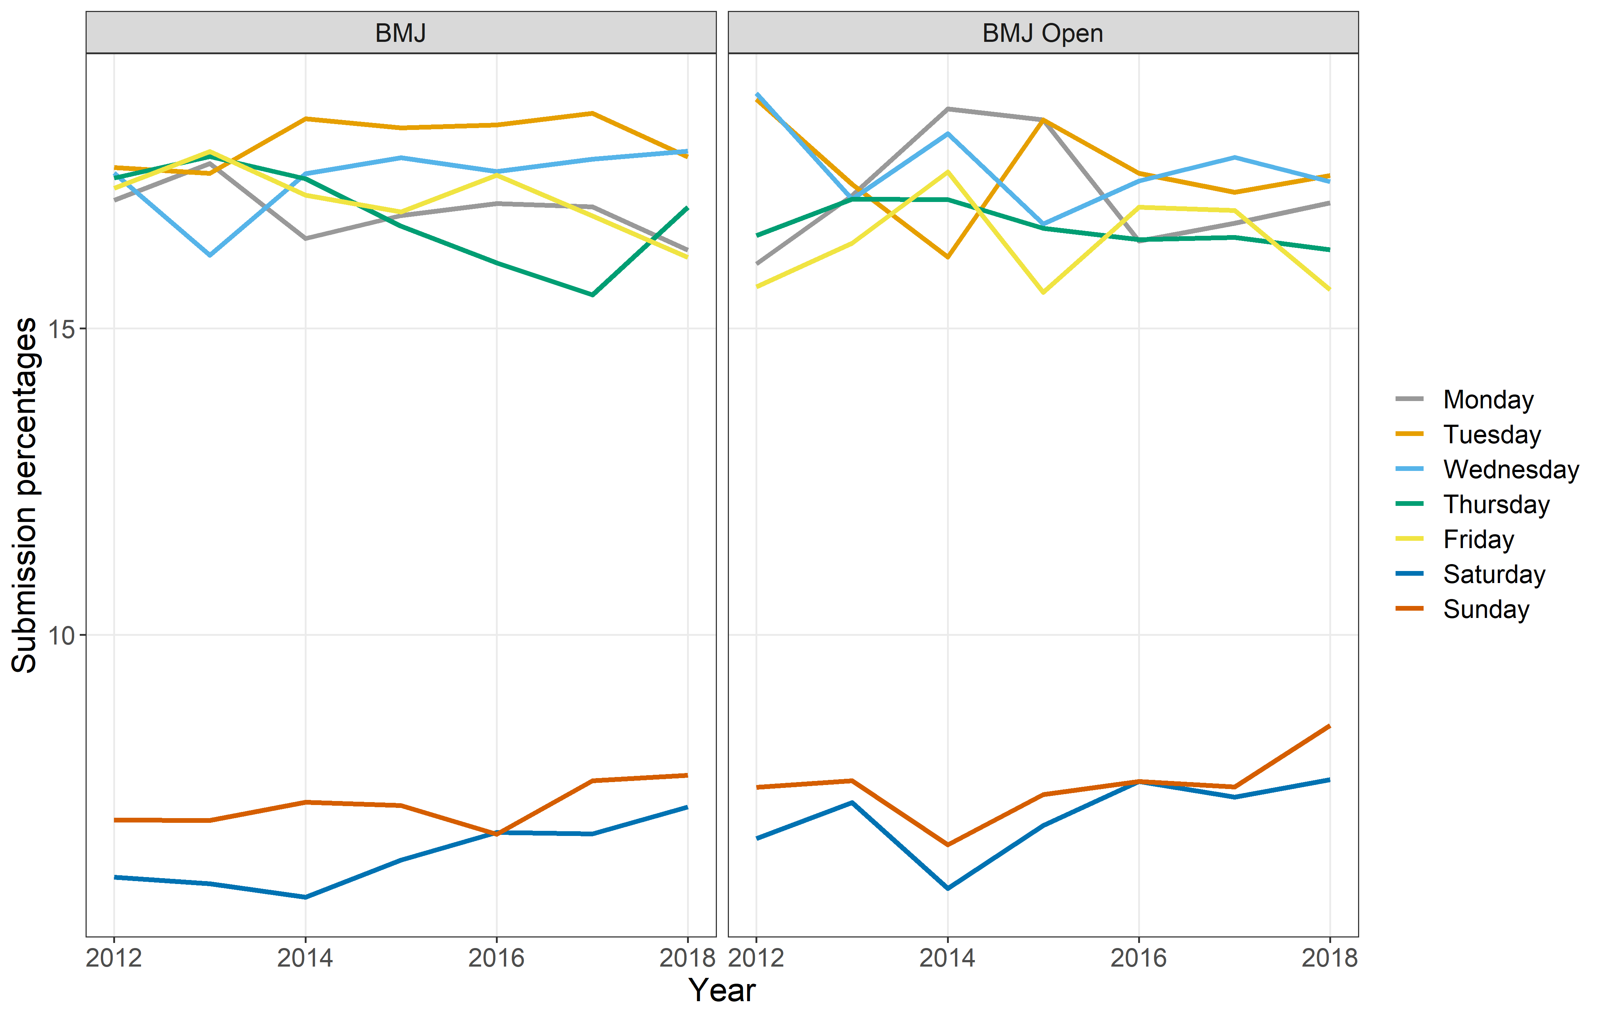

### Reviews

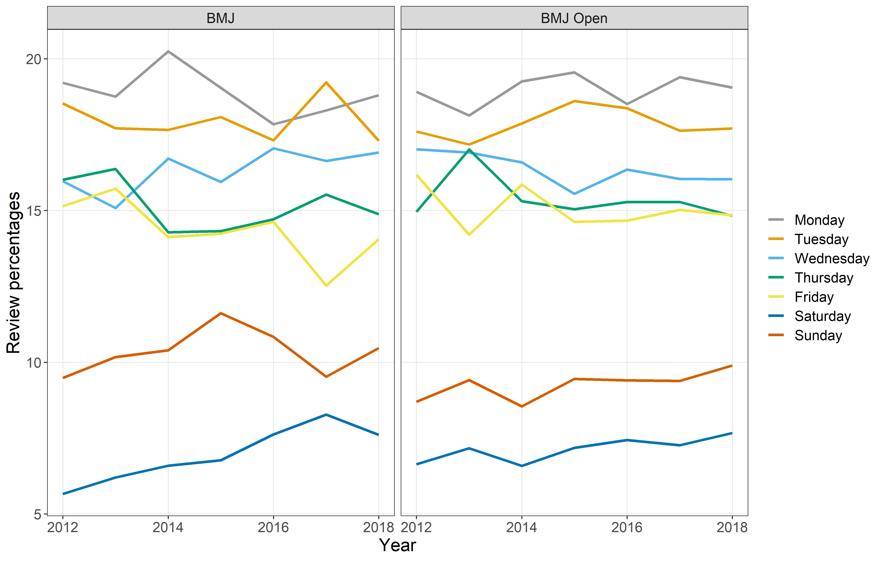

The most common day for reviews was Monday and the least common day was Saturday.

## Plot of weekend percents by week-to-week results

The plots below aim to examine the trend over time in weekend submissions and reviews. They show the Weekly percentage of submitted papers and reviewers on the weekend. The blue line is a non-linear smooth using a loess with a span of 0.75.

### Submissions

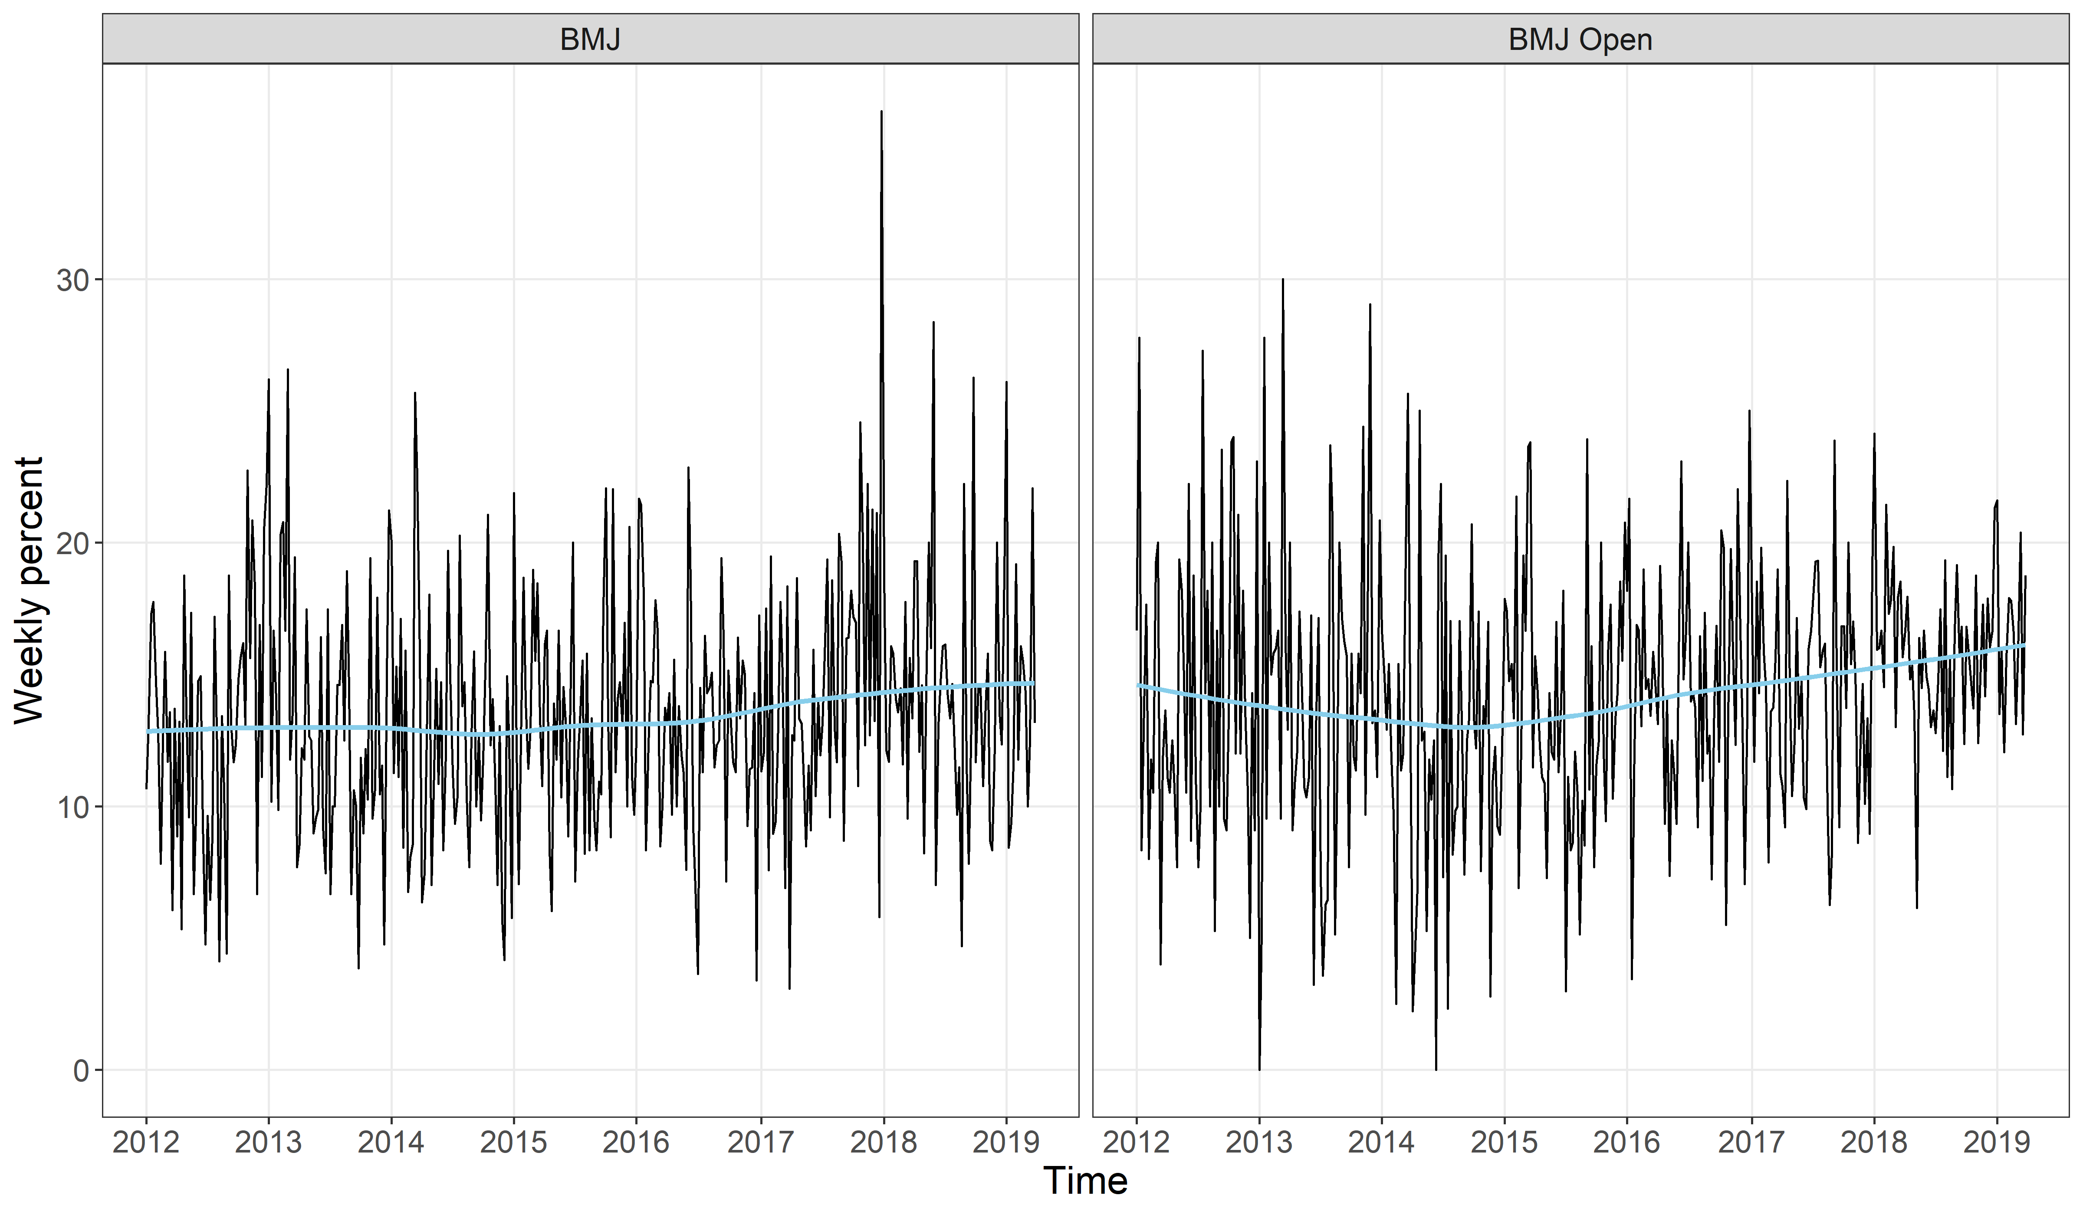

The estimated trends shows a small increase in weekend submissions over time.

### Reviews

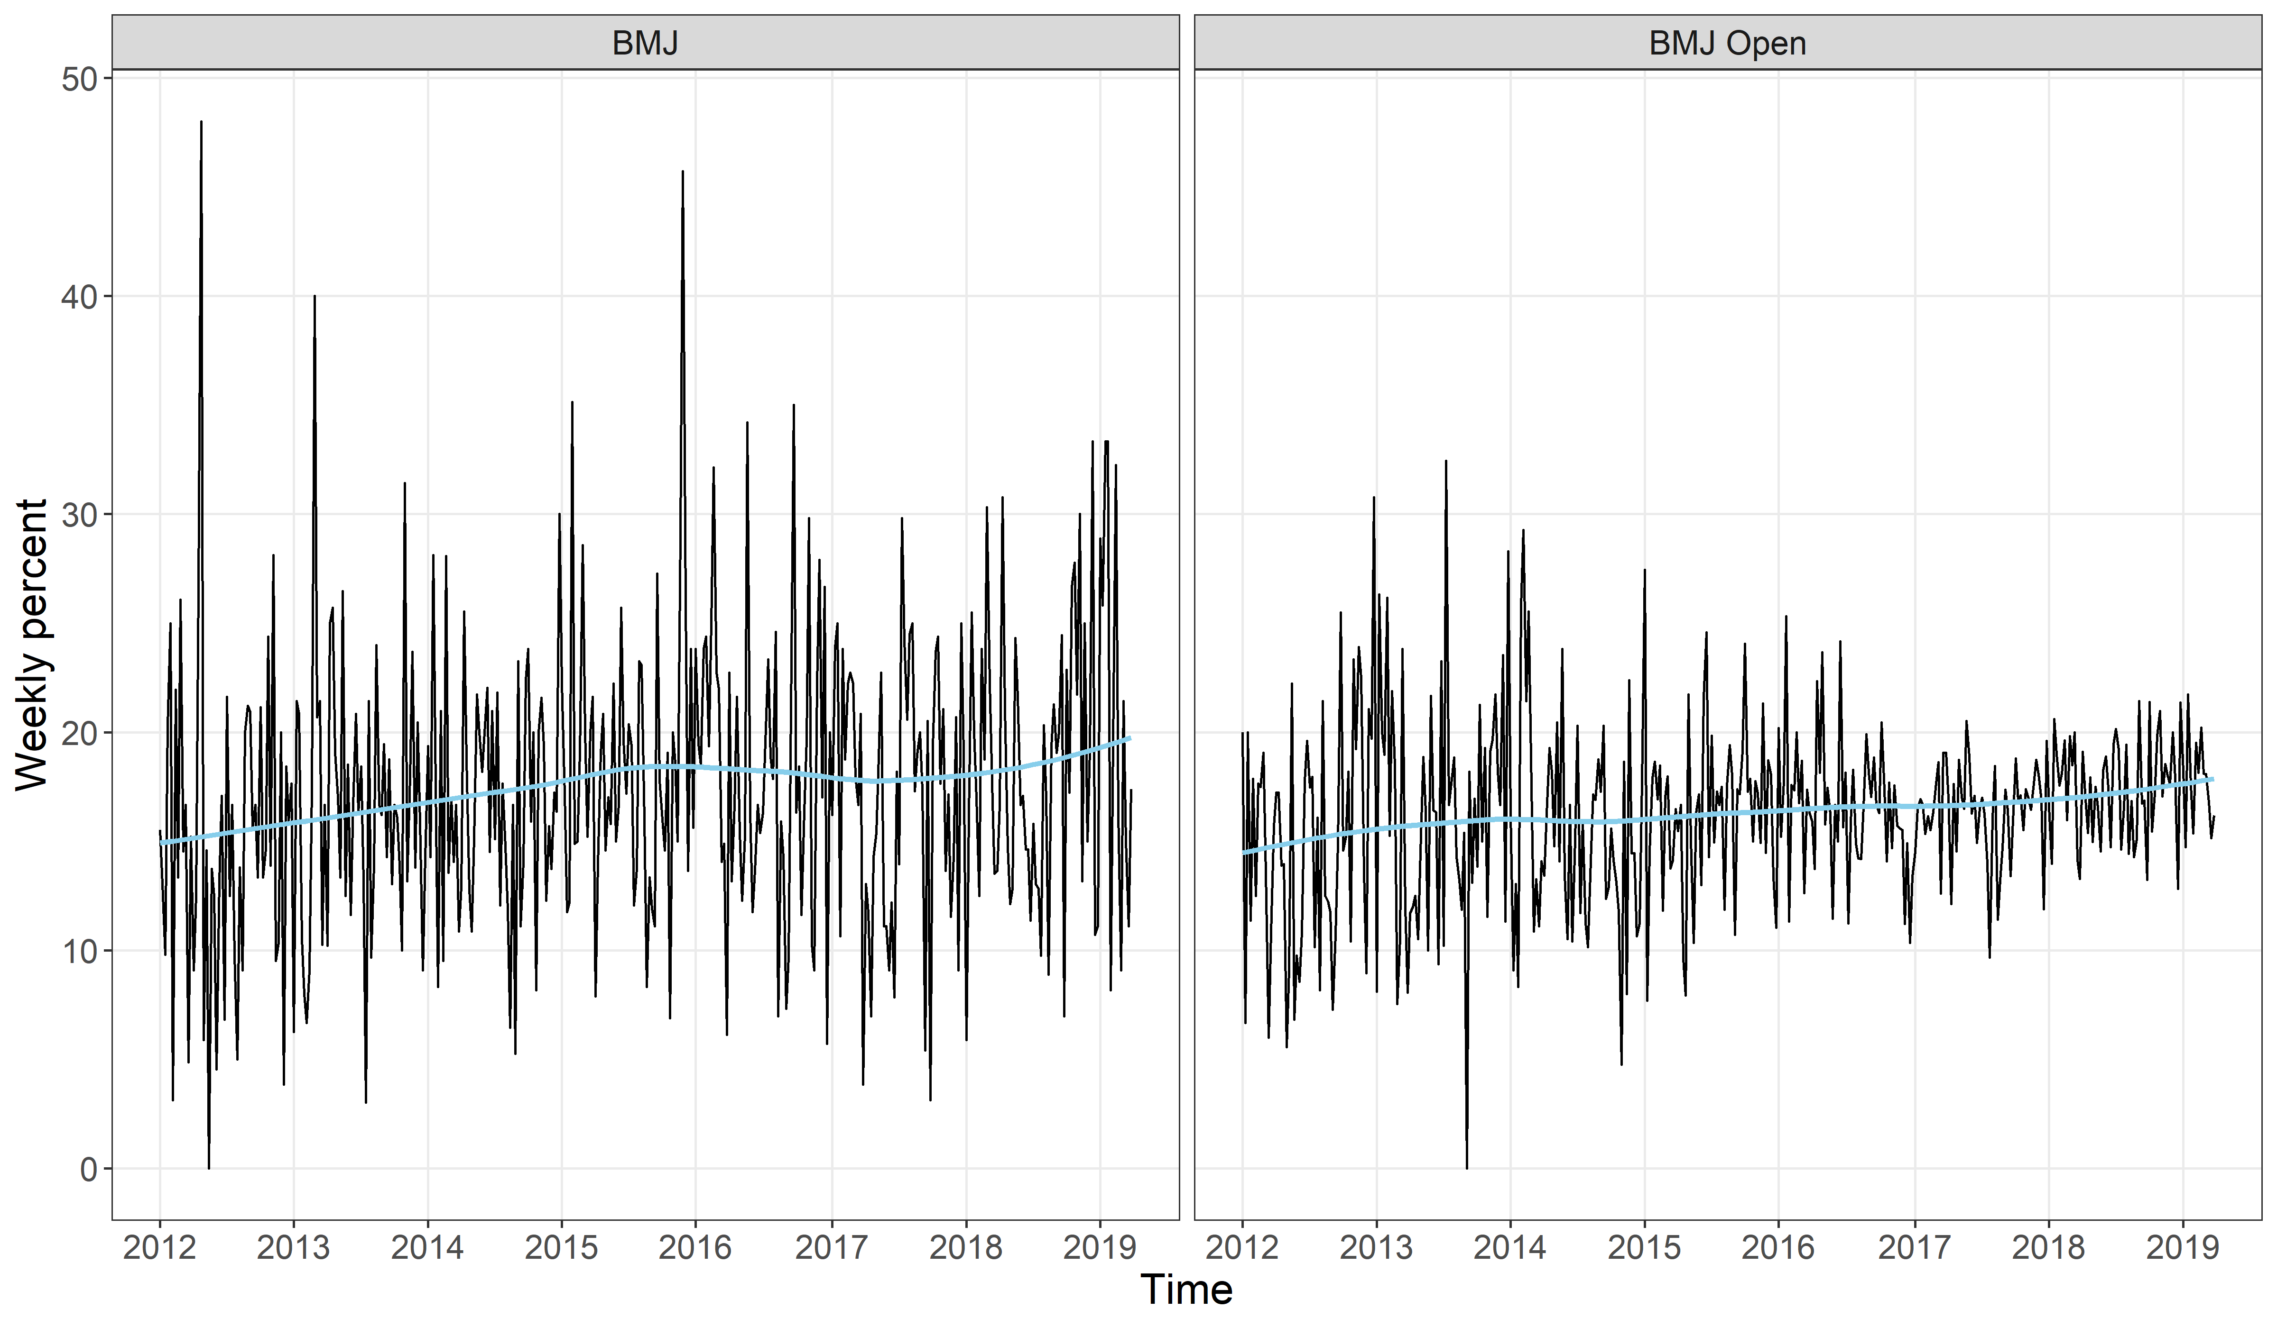

There does appear to be a small increase over time in weekend reviews, especially for BMJ Open.

# Statistical models - weekend submissions

Here we examine a relative increase in weekend submissions over time using a binomial model. We run separate models in each of the two journals. We used a country-specific intercept for each country to control for differences between countries in the probability of submitting on the weekend. We plot the country-specific intercepts to show the differences between countries. We exclude countries with small numbers from the plots.

In terms of the change over time in weekend submissions, we use two models. The simpler model assumes the change is the same in every country. The more complex model allows a country-specific change over time. We plot the country-specific changes.

We examine a seasonal pattern in submissions using a sinusoidal model with an annual cycle. We allow the seasonal pattern to vary by country. We plot the overall season pattern and the phase and amplitude in each country. The phase is the timing of the seasonal peak and the amplitude is its height.

We compare the fit of the models using the deviance information criterion.

## BMJ weekend submissions

This section examines journal submissions on the weekend to the BMJ.

### Best fitting model

First we examine the deviance information criterion (DIC) to find the best model

|  |  |  |  |  |
| --- | --- | --- | --- | --- |
| model | season | pD | DIC | Difference |
| slope | Season | 105 | 10,529 | 0 |
| intercept | Season | 75 | 10,536 | 7 |
| slope | NoSeason | 59 | 10,557 | 28 |
| intercept | NoSeason | 29 | 10,567 | 38 |

The best model (smallest DIC) has both a country-specific slope and a seasonal pattern. Hence we show the results for this model below.

### Table of parameter estimates for best model for weekend submissions to BMJ

|  |  |  |
| --- | --- | --- |
| variable | Mean | 95% CI |
| Intercept, logit scale | -1.832 | -1.907, -1.757 |
| Change, logit scale | -0.018 | -0.112, 0.074 |
| Cos season, logit scale | 0.090 | -0.055, 0.247 |
| Sin season, logit scale | 0.011 | -0.149, 0.18 |
| Probability, 2012 | 0.138 | 0.129, 0.147 |
| Probability, 2013 | 0.136 | 0.121, 0.151 |
| Difference | -0.002 | -0.013, 0.009 |
| Ratio | 0.985 | 0.907, 1.065 |

The intercept is the overall average and the change is the annual change in probability. Both are on a logit scale because we used a binomial model. The two estimated probabilities are for 2012 and 2013 and are used to show the annual difference in weekend submissions. The difference is the absolute increase in probability per year. The ratio is the relative change in probability per year.

There was little change over time in the probability of submitting on the weekend.

### Plot of country-specific intercepts and 95% credible intervals for weekend submissions to BMJ

The plot below shows the estimated weekend probability in each country. The aim is to look for interesting differences between countries in the probability of submitting papers on the weekend. The 95% credible intervals are wider for countries with fewer submissions. The countries are ordered by their mean probability, making it easier to spot patterns which countries have similar means.

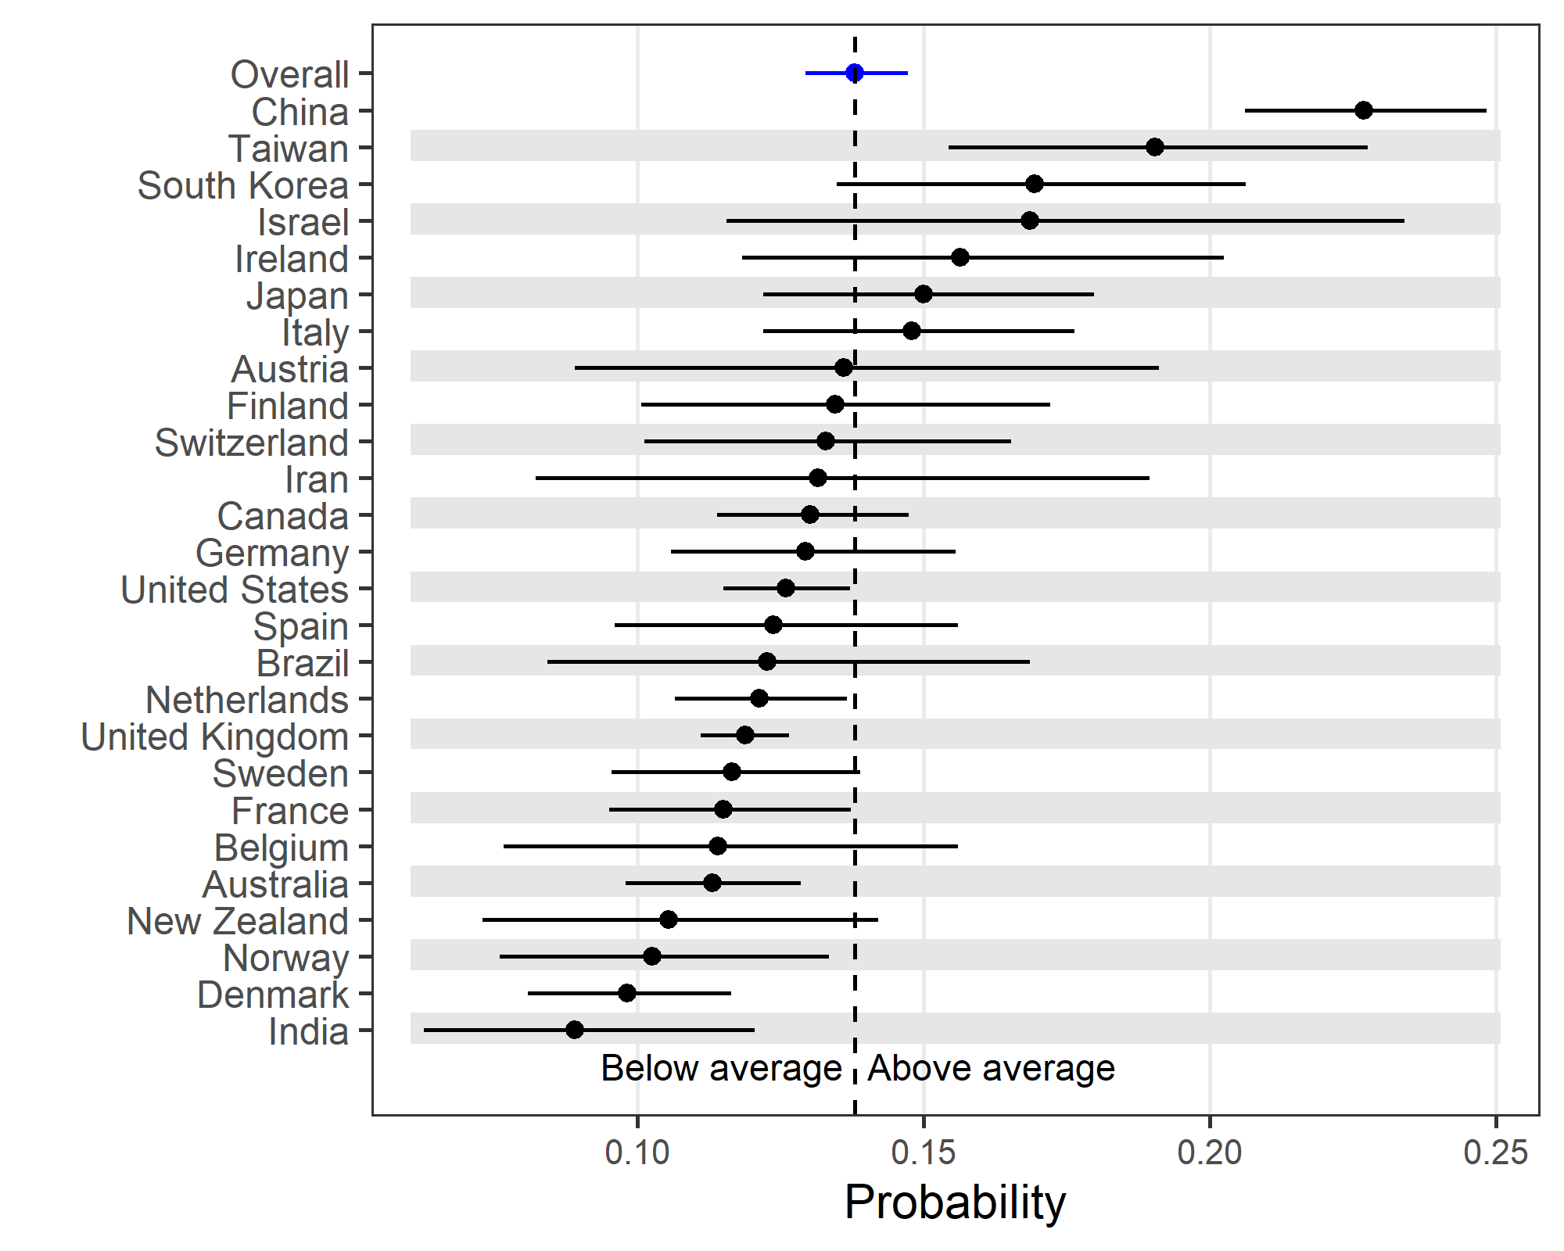

There are large differences between countries in the probability of submitting on the weekend. The lowest average probability is in India and the highest average in China. In China the probability is very high and almost equivalent to an equal probability on any day of the week as 2 days out of 7 is a probability of 0.29.

### Plot of country-specific slopes and 95% credible intervals for weekend submissions to BMJ

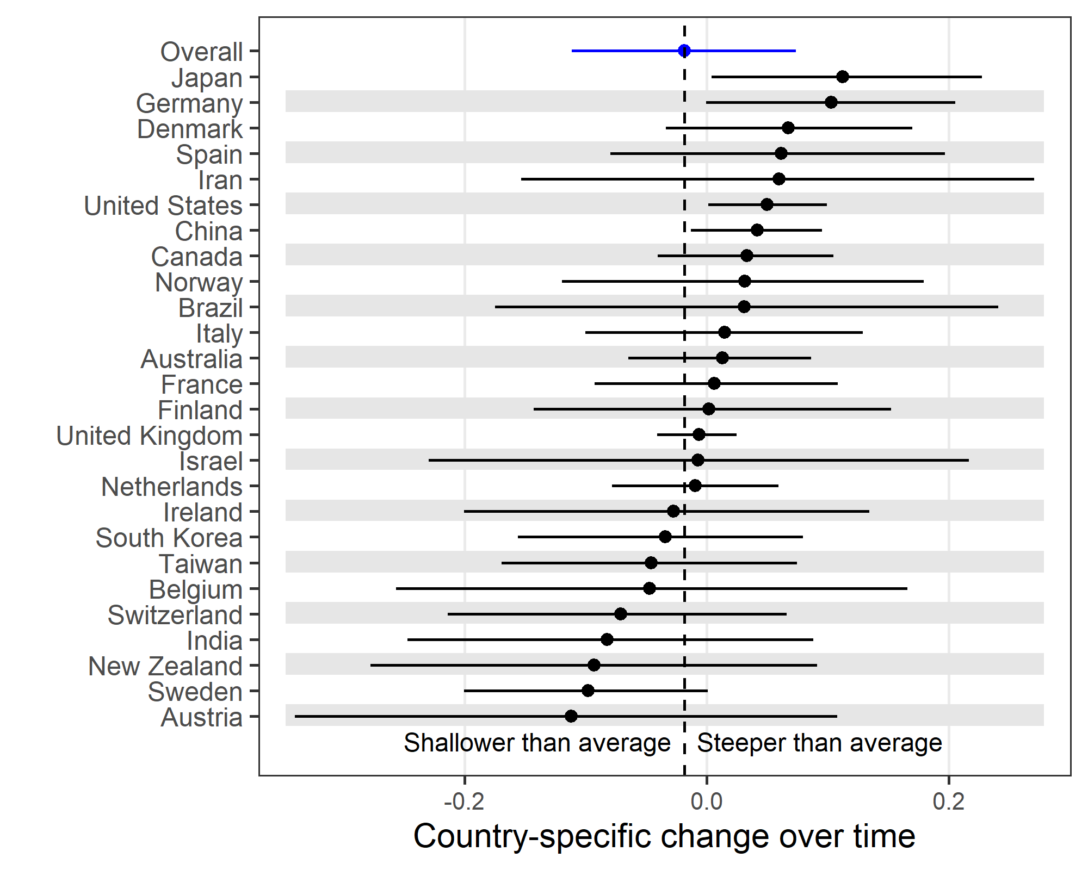

The dotted vertical line is the average change over time, which is close to zero indicating no change across all countries. Japan has the largest average increase over time in weekend submissions and Austria the smallest average.

### Plot of seasonal estimates for weekend submissions to BMJ

The plots are: i) the average sinusoidal seasonal pattern, ii) the country-specific seasonal pattern using a circular plot. The position of the dot shows the phase, which is the location of the peak. January is at 12 o’clock on the circle and July at 6 o’clock. Dots close to the centre have only a weak seasonal pattern, whereas those further towards the edge have a stronger seasonal pattern (amplitude).

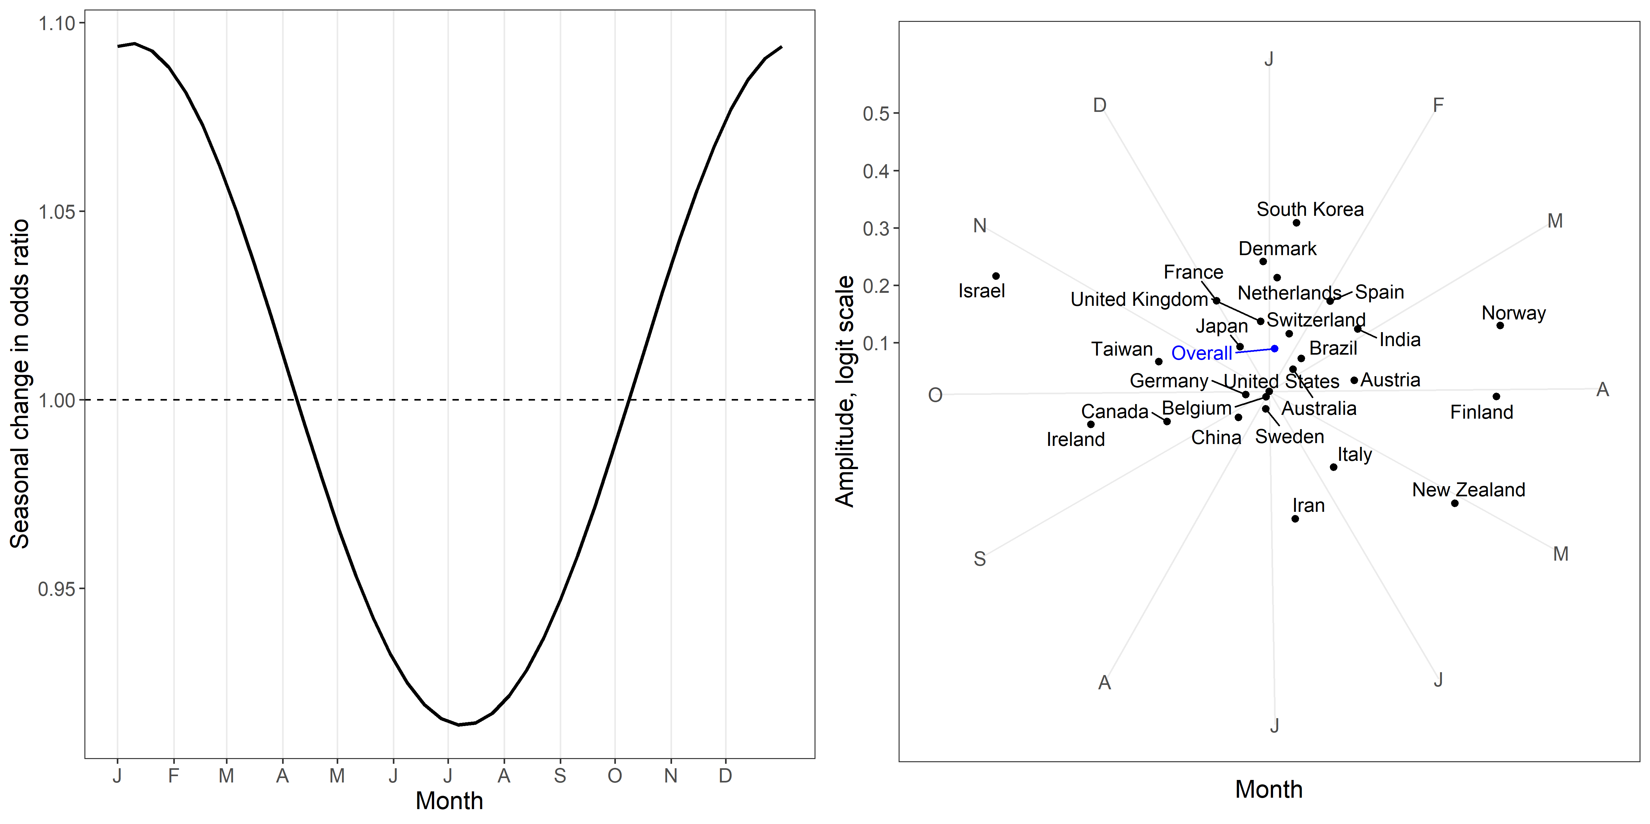

The seasonal pattern in submissions peaks in January with an odds ratio of 1.1. The country-specific estimates show a number of countries close to the centre, meaning they have little seasonal pattern. The strongest seasonal patterns are in Israel, Iran, Finland, New Zealand, and Norway.

## BMJ Open weekend submissions

This section examines journal submissions on the weekend to BMJ Open.

### Best fitting model

First we examine the deviance information criterion (DIC) to find the best model

|  |  |  |  |  |
| --- | --- | --- | --- | --- |
| model | season | pD | DIC | Difference |
| slope | Season | 113 | 10,320 | 0 |
| slope | NoSeason | 64 | 10,326 | 6 |
| intercept | Season | 80 | 10,335 | 15 |
| intercept | NoSeason | 32 | 10,341 | 21 |

The best model has a country-specific slope and season, hence we show the results for this model below.

### Table of parameter estimates for best model for weekend submissions to BMJ Open

|  |  |  |
| --- | --- | --- |
| variable | Mean | 95% CI |
| Intercept, logit scale | -1.833 | -1.896, -1.768 |
| Change, logit scale | 0.005 | -0.088, 0.098 |
| Cos season, logit scale | 0.116 | -0.015, 0.248 |
| Sin season, logit scale | 0.028 | -0.106, 0.152 |
| Probability, 2012 | 0.138 | 0.131, 0.146 |
| Probability, 2013 | 0.139 | 0.127, 0.153 |
| Difference | 0.001 | -0.01, 0.012 |
| Ratio | 1.005 | 0.926, 1.088 |

There was almost no difference in the overall probability of weekend submissions over time.

### Plot of country-specific intercepts and 95% credible intervals for weekend submissions to BMJ Open

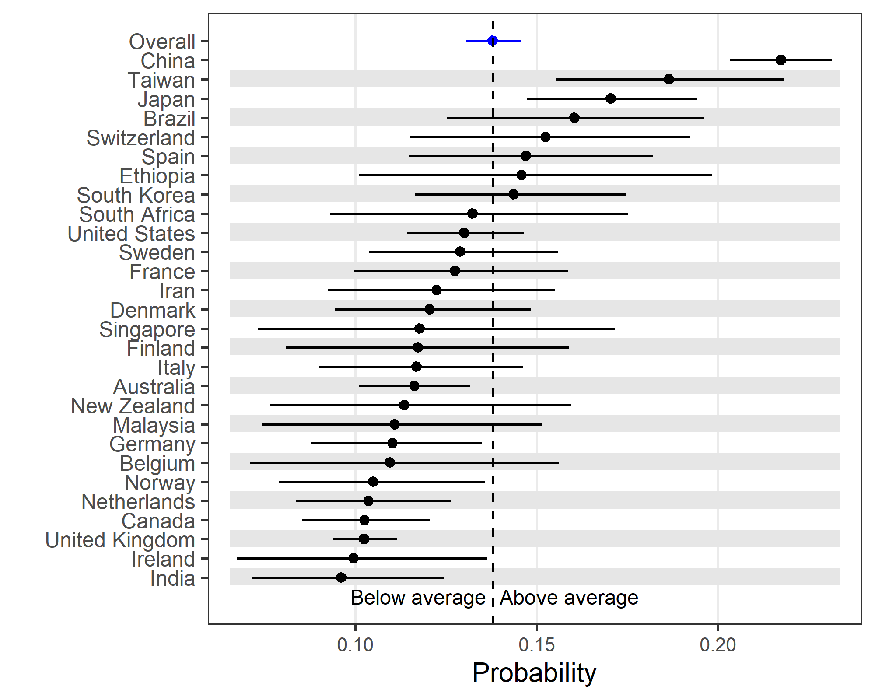

There is a very large difference between countries in the probability of weekend submissions to BMJ Open. China and Taiwan both also have relatively high probabilities of weekend submissions.

### Plot of country-specific slopes and 95% credible intervals for weekend submissions to BMJ Open

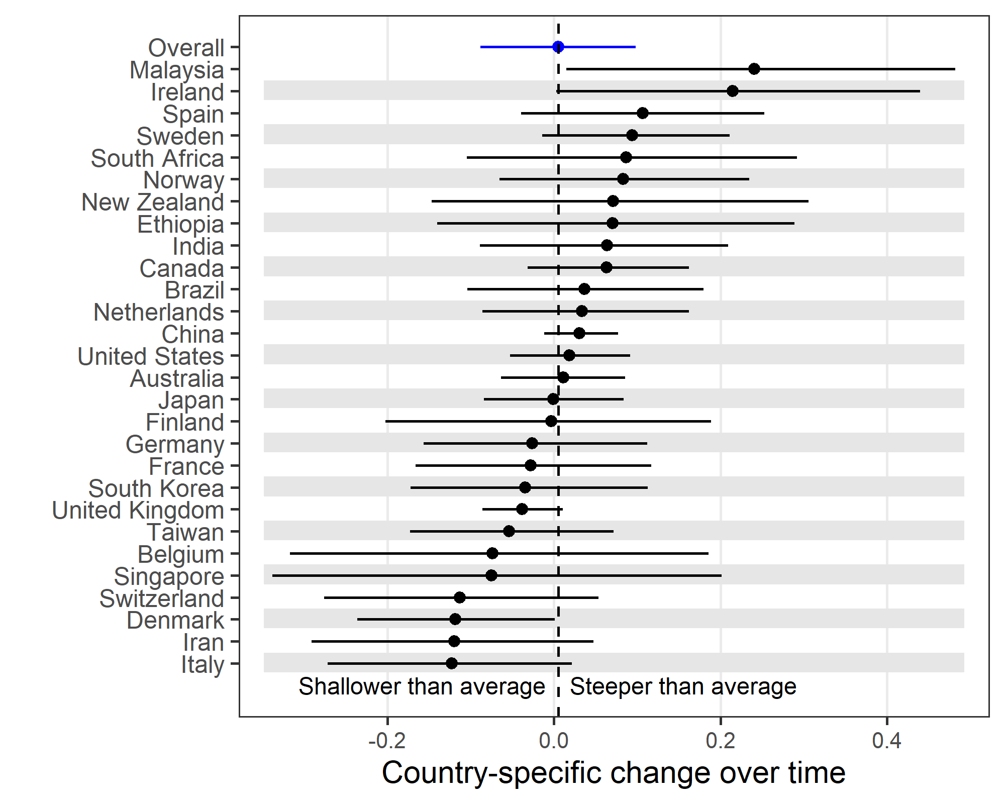

The dotted vertical line is the mean which is close to zero meaning no change across all countries. Malaysia had the largest mean increase in weekend submissions over time, but the uncertainty around this mean was large.

# Statistical models - weekend reviews

In this section we examine reviews on the weekend.

## BMJ weekend reviews

This section examines journal reviews on the weekend to the BMJ.

### Best fitting model for BMJ weekend reviews

First we examine the deviance information criterion (DIC) to find the best model

|  |  |  |  |  |
| --- | --- | --- | --- | --- |
| model | season | pD | DIC | Difference |
| slope | Season | 94 | 8,071 | 0 |
| intercept | Season | 67 | 8,079 | 8 |
| slope | NoSeason | 53 | 8,107 | 36 |
| intercept | NoSeason | 25 | 8,112 | 41 |

### Table of parameter estimates for best model for weekend reviews to BMJ

|  |  |  |
| --- | --- | --- |
| variable | Mean | 95% CI |
| Intercept, logit scale | -1.540 | -1.634, -1.447 |
| Change, logit scale | 0.014 | -0.096, 0.117 |
| Cos season, logit scale | 0.070 | -0.109, 0.258 |
| Sin season, logit scale | -0.015 | -0.181, 0.15 |
| Probability, 2012 | 0.177 | 0.163, 0.19 |
| Probability, 2013 | 0.179 | 0.158, 0.199 |
| Difference | 0.002 | -0.013, 0.018 |
| Ratio | 1.012 | 0.923, 1.099 |

There was no change in the probability of weekend reviews over time.

### Plot of country-specific intercepts and 95% credible intervals for weekend reviews to BMJ

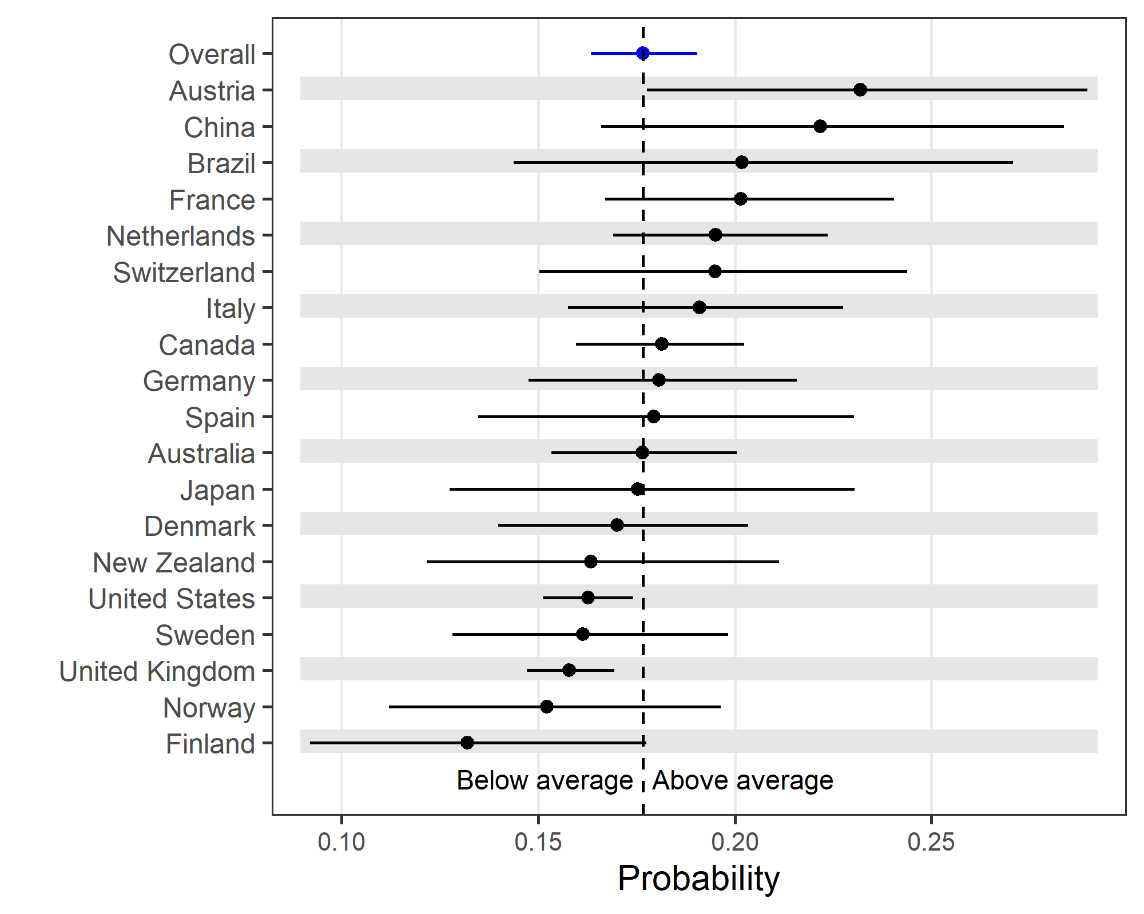

Finland had the lowest probability of weekend reviews and Austria the highest.

### Plot of country-specific slopes and 95% credible intervals for weekend reviews to BMJ

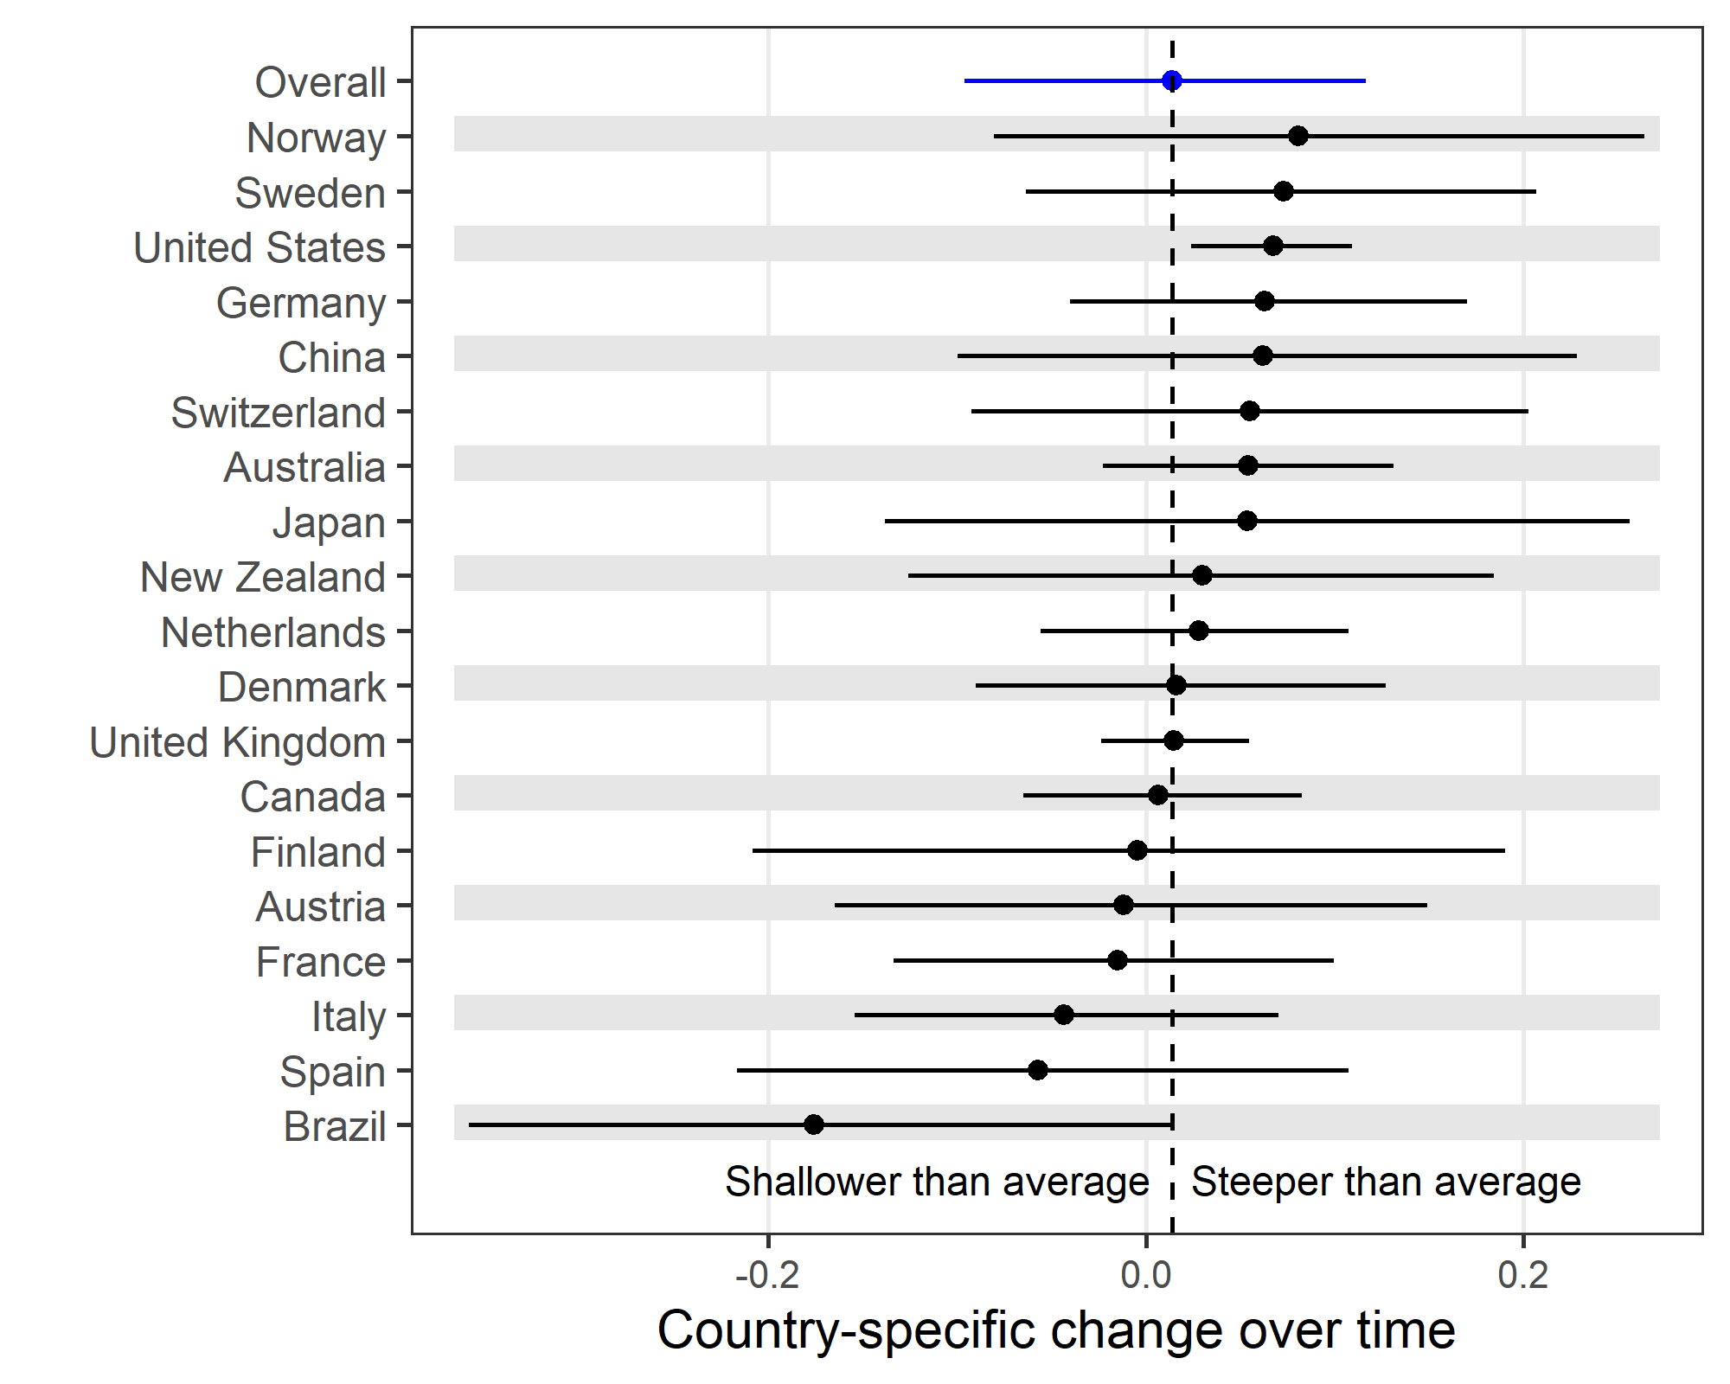

There was a relatively small variation in slopes between countries.

### Plot of seasonal estimates for weekend reviews to BMJ

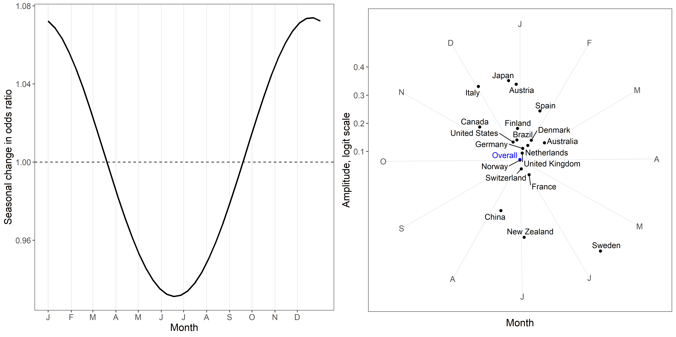

The seasonal pattern was mixed. A relatively large number of countries peaked in December and January. Sweden was a notable outlier with a peak in late May.

## BMJ Open weekend reviews

This section examines journal reviews on the weekend to the BMJ Open.

### Best fitting model for BMJ Open weekend reviews

First we examine the deviance information criterion (DIC) to find the best model

|  |  |  |  |  |
| --- | --- | --- | --- | --- |
| model | season | pD | DIC | Difference |
| intercept | Season | 92 | 16,491 | 0 |
| slope | Season | 121 | 16,491 | 0 |
| intercept | NoSeason | 35 | 16,512 | 21 |
| slope | NoSeason | 67 | 16,516 | 25 |

There is almost a tie for the best model between a seasonal model with a country-specific slope and common slope. We choose the common slope because this is the simpler model.

### Table of parameter estimates for best model for weekend reviews to BMJ Open

|  |  |  |
| --- | --- | --- |
| variable | Mean | 95% CI |
| Intercept, logit scale | -1.540 | -1.586, -1.496 |
| Change, logit scale | 0.029 | -0.061, 0.123 |
| Cos season, logit scale | -0.020 | -0.137, 0.094 |
| Sin season, logit scale | -0.018 | -0.136, 0.1 |
| Probability, 2012 | 0.177 | 0.17, 0.183 |
| Probability, 2013 | 0.181 | 0.167, 0.195 |
| Difference | 0.004 | -0.009, 0.018 |
| Ratio | 1.025 | 0.951, 1.106 |

There was a very small increase in weekend reviews over time.

### Plot of country-specific intercepts and 95% credible intervals for weekend reviews to BMJ Open

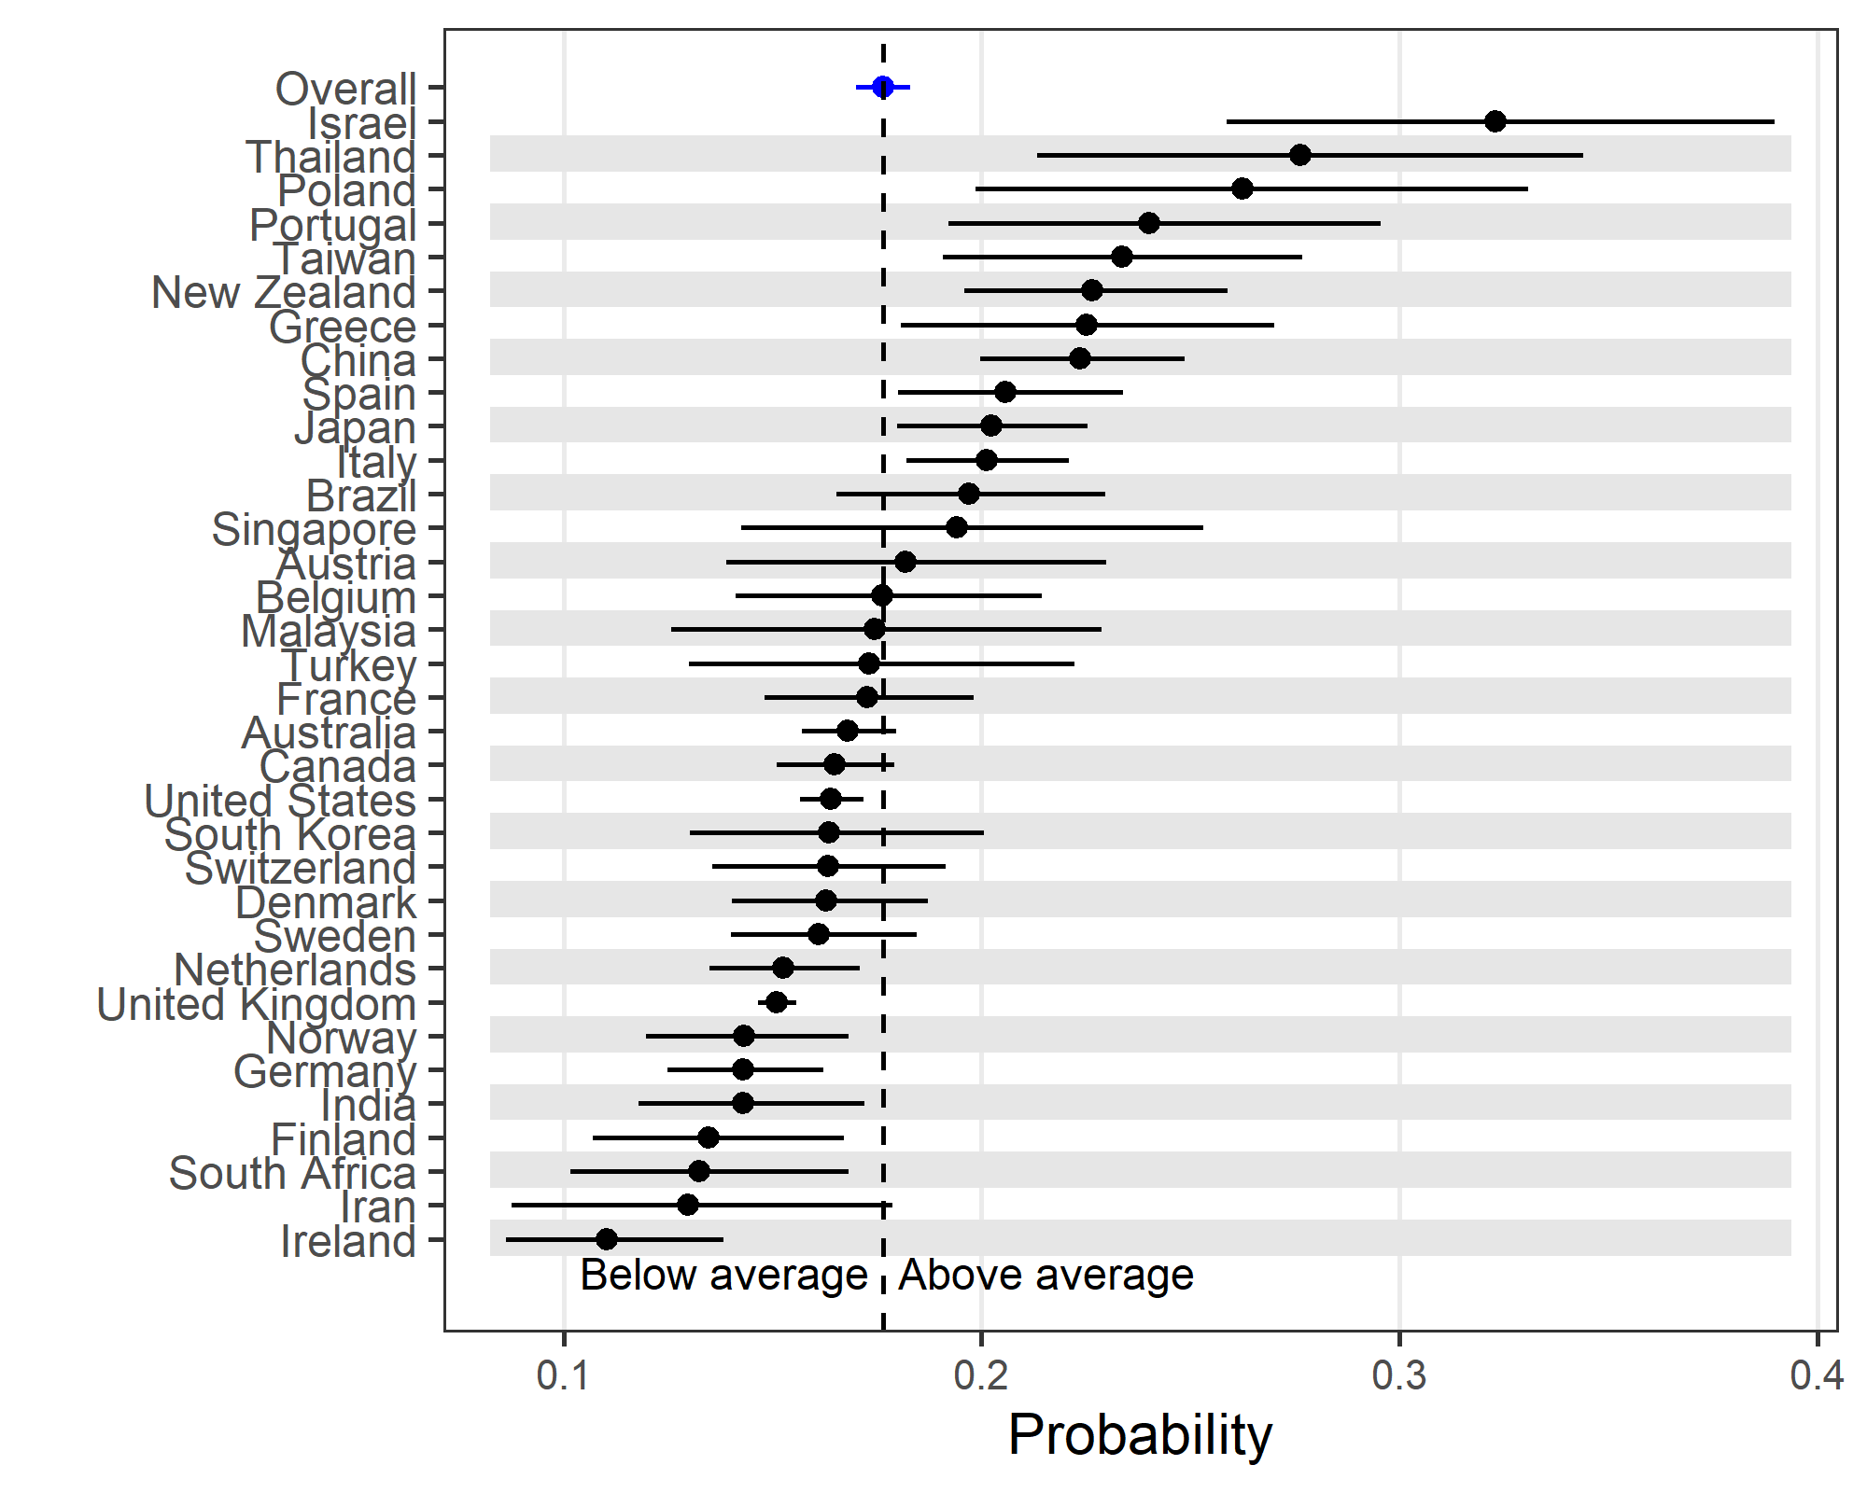

There is a large variability between countries in the probability of weekend reviews. The highest probability is in Israel and the lowest in Ireland.

### Plot of seasonal estimates for weekend reviews to BMJ Open

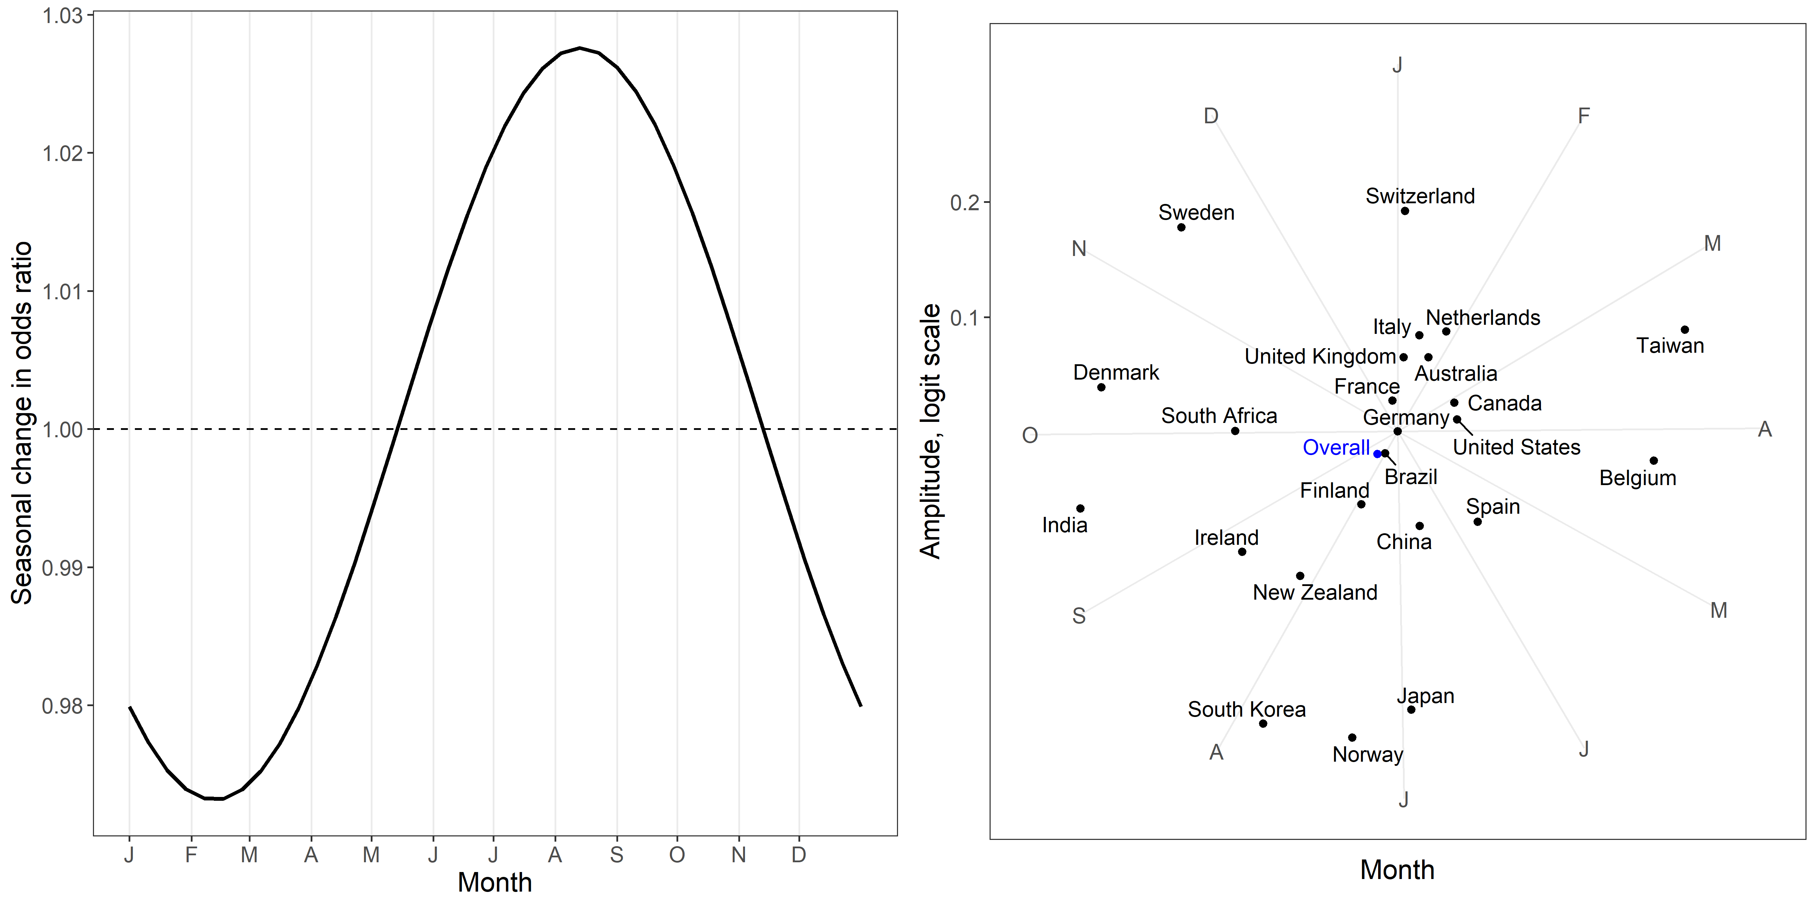

There is a relatively weak season pattern of a peak in odds of over 1.02 in August. The strongest seasonal patterns are in Norway, Japan and South Korea.

# Holidays

In this section we examine the probability of submissions and reviews on national holidays. We only examine weeks that included a holiday and model the probability of a submission or review on a holiday compared with the other days in that week.

## Submissions to BMJ

|  |  |  |
| --- | --- | --- |
| variable | Mean | 95% CI |
| Intercept, logit scale | -1.709 | -1.753, -1.666 |
| Change, logit scale | 0.000 | -0.02, 0.019 |
| Probability, 2012 | 0.153 | 0.148, 0.159 |
| Probability, 2013 | 0.153 | 0.147, 0.159 |
| Difference | 0.000 | -0.003, 0.002 |
| Ratio | 1.000 | 0.983, 1.016 |

### Plot of country-specific intercepts and 95% credible intervals for holiday submissions to BMJ

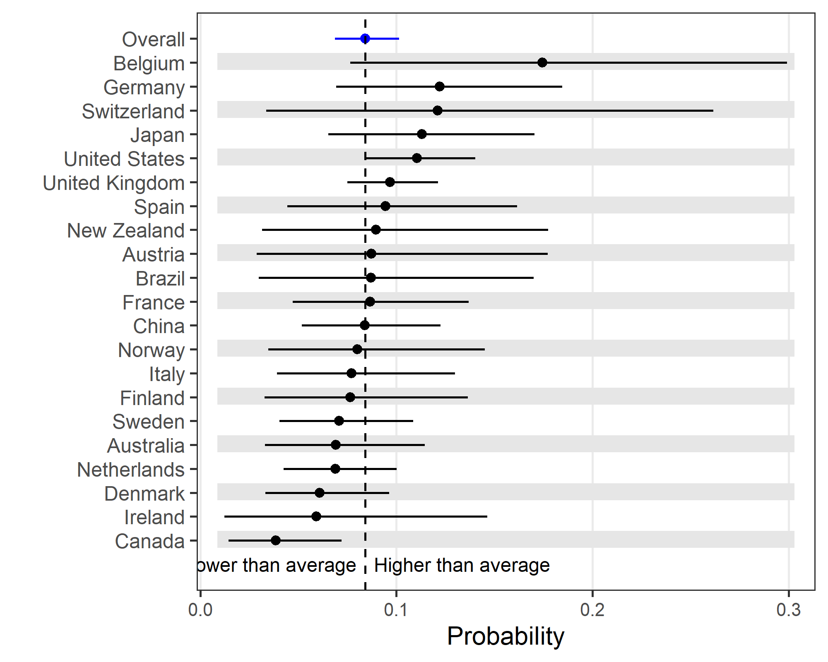

## Submissions to BMJ Open

|  |  |  |
| --- | --- | --- |
| variable | Mean | 95% CI |
| Intercept, logit scale | -1.727 | -1.772, -1.683 |
| Change, logit scale | -0.003 | -0.026, 0.019 |
| Probability, 2012 | 0.151 | 0.145, 0.157 |
| Probability, 2013 | 0.151 | 0.145, 0.157 |
| Difference | 0.000 | -0.003, 0.002 |
| Ratio | 0.997 | 0.978, 1.016 |

### Plot of country-specific intercepts and 95% credible intervals for holiday submissions to BMJ Open

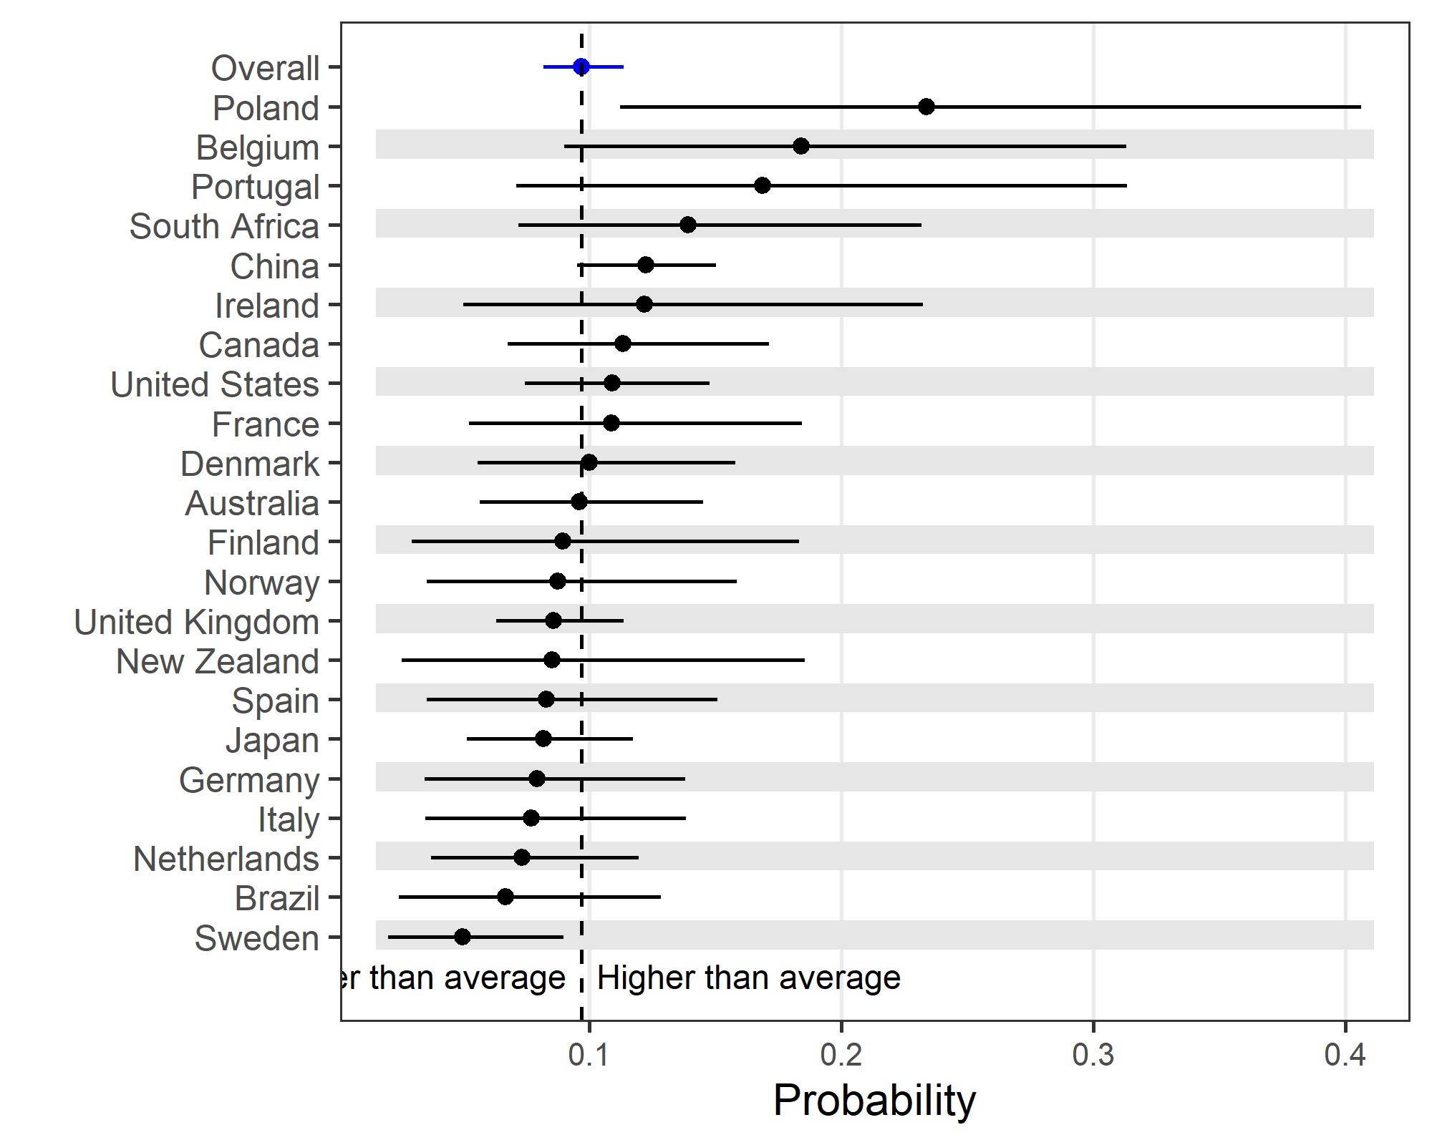

## Reviews to BMJ

|  |  |  |
| --- | --- | --- |
| variable | Mean | 95% CI |
| Intercept, logit scale | -1.765 | -1.814, -1.716 |
| Change, logit scale | 0.000 | -0.022, 0.024 |
| Probability, 2012 | 0.146 | 0.14, 0.152 |
| Probability, 2013 | 0.146 | 0.14, 0.153 |
| Difference | 0.000 | -0.003, 0.003 |
| Ratio | 1.000 | 0.981, 1.021 |

### Plot of country-specific intercepts and 95% credible intervals for holiday reviews to BMJ

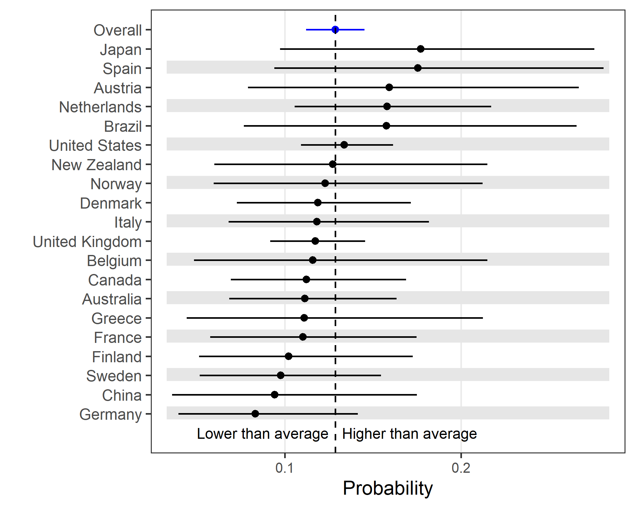

## Reviews to BMJ Open

|  |  |  |
| --- | --- | --- |
| variable | Mean | 95% CI |
| Intercept, logit scale | -1.755 | -1.784, -1.727 |
| Change, logit scale | 0.000 | -0.014, 0.015 |
| Probability, 2012 | 0.147 | 0.144, 0.151 |
| Probability, 2013 | 0.147 | 0.144, 0.151 |
| Difference | 0.000 | -0.002, 0.002 |
| Ratio | 1.000 | 0.988, 1.013 |

### Plot of country-specific intercepts and 95% credible intervals for holiday reviews to BMJ Open

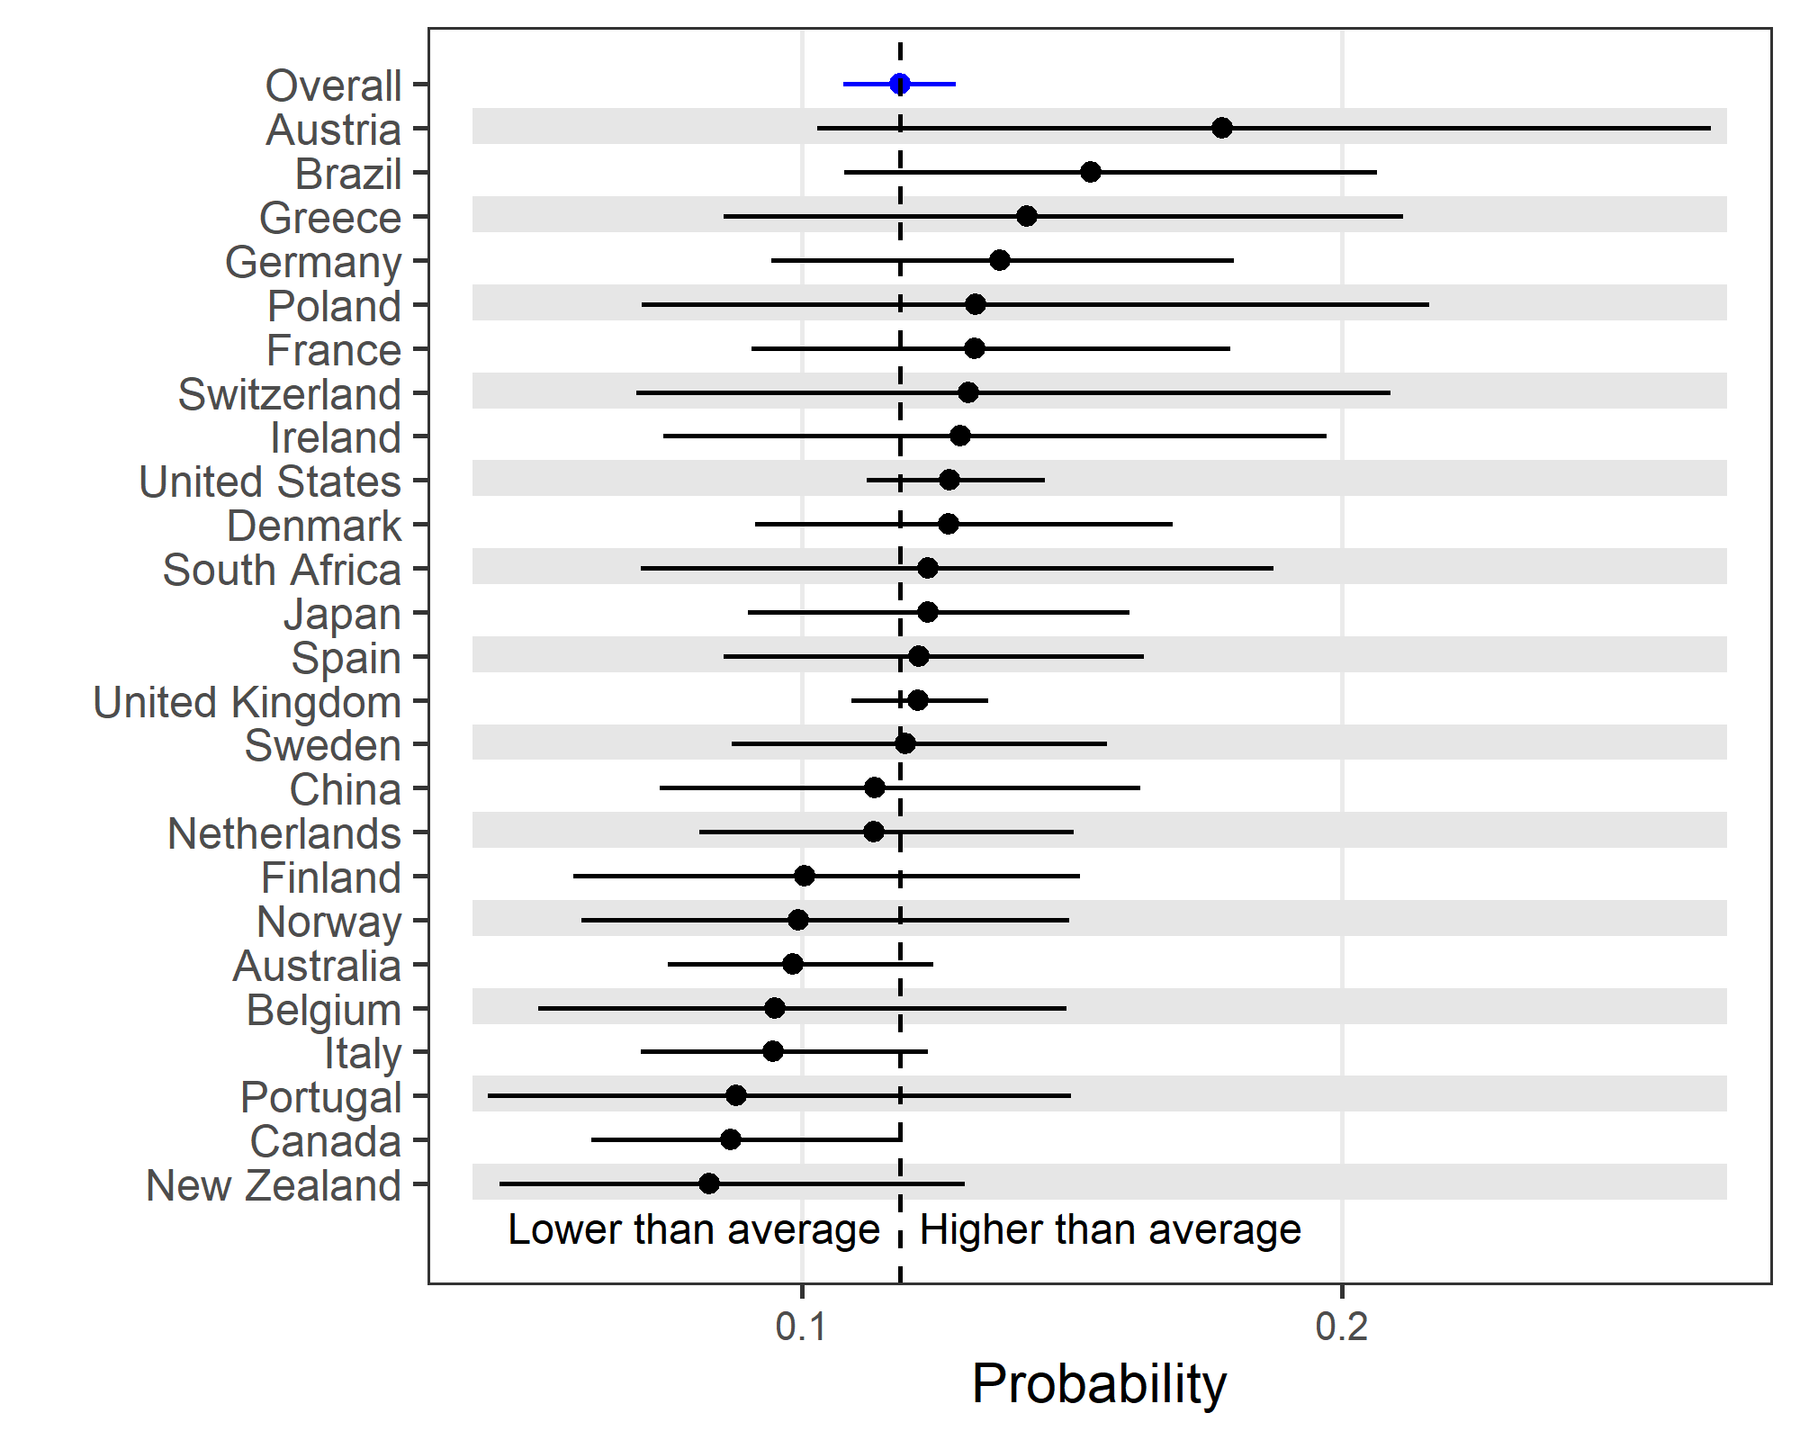

# Late nights and early mornings

In this section we examine late nights and early mornings. We previously used a simple dichotomous definition of late nights and early mornings versus working hours, which was after 6pm or before 7am. Here we instead examine the results over the 24-hour clock and examine differences between countries.

We use a Poisson model for submissions and reviews:

$n_{h,j}∼Poisson(μ_{h,j}), h=1…24, j=1,…,C$,

where $n_{h,j}$ is the number of reviews or submissions in hour $h$ in country $j$ and there are $C$ countries in total. The regression equation is:

$\text{log}(μ_{h,j})=\text{log}(N_{j})+α+(β_{h}−\overline{β})+γ_{j,1}\text{cos}[2π(h−1)/24]+γ_{j,2}\text{sin}[2π(h−1)/24]$,

where $N_{j}$ is an offset as it is the total number of reviews or submissions in country $j$ and $α$ is the overall intercept with non-informative prior $α∼N(0,{10}^{4})$. The $β$’s are the average effect in each hour defined as:

$β_{h}∼N(0,τ_{β}^{−1}), h=1,…,24,$

and we subtract the overall mean $β$ in the regression equation so that these estimates are the difference from the average. The prior for the inverse variance uses a Gamma distribution $τ_{β}∼Ga(1,1)$.

The cosine and sine functions combine to create a smooth sinusoidal wave for each country that has one peak at any time during the 24-hour clock. To ensure that the sinusoid was centred around the average, we subtracted the overall mean using:

$γ_{j,k}=γ_{j,k}^{*}−{\overline{γ}}_{k}$,

with non-informative priors for the $γ^{*}$’s:

$γ_{j,k}^{*}∼N(0,{10}^{4}), j=1,…,C, k=1,2$.

This meant that for a country with $γ_{j,1}=γ_{j,2}=0$, that country had no difference in submission or reviews times over the 24-hour clock from the overall average.

We used 2 chains each with 5000 estimates thinned by 3.

## Peak time for submissions by country

The scatter plot below shows the timing and size of the peak in reviews for each country.

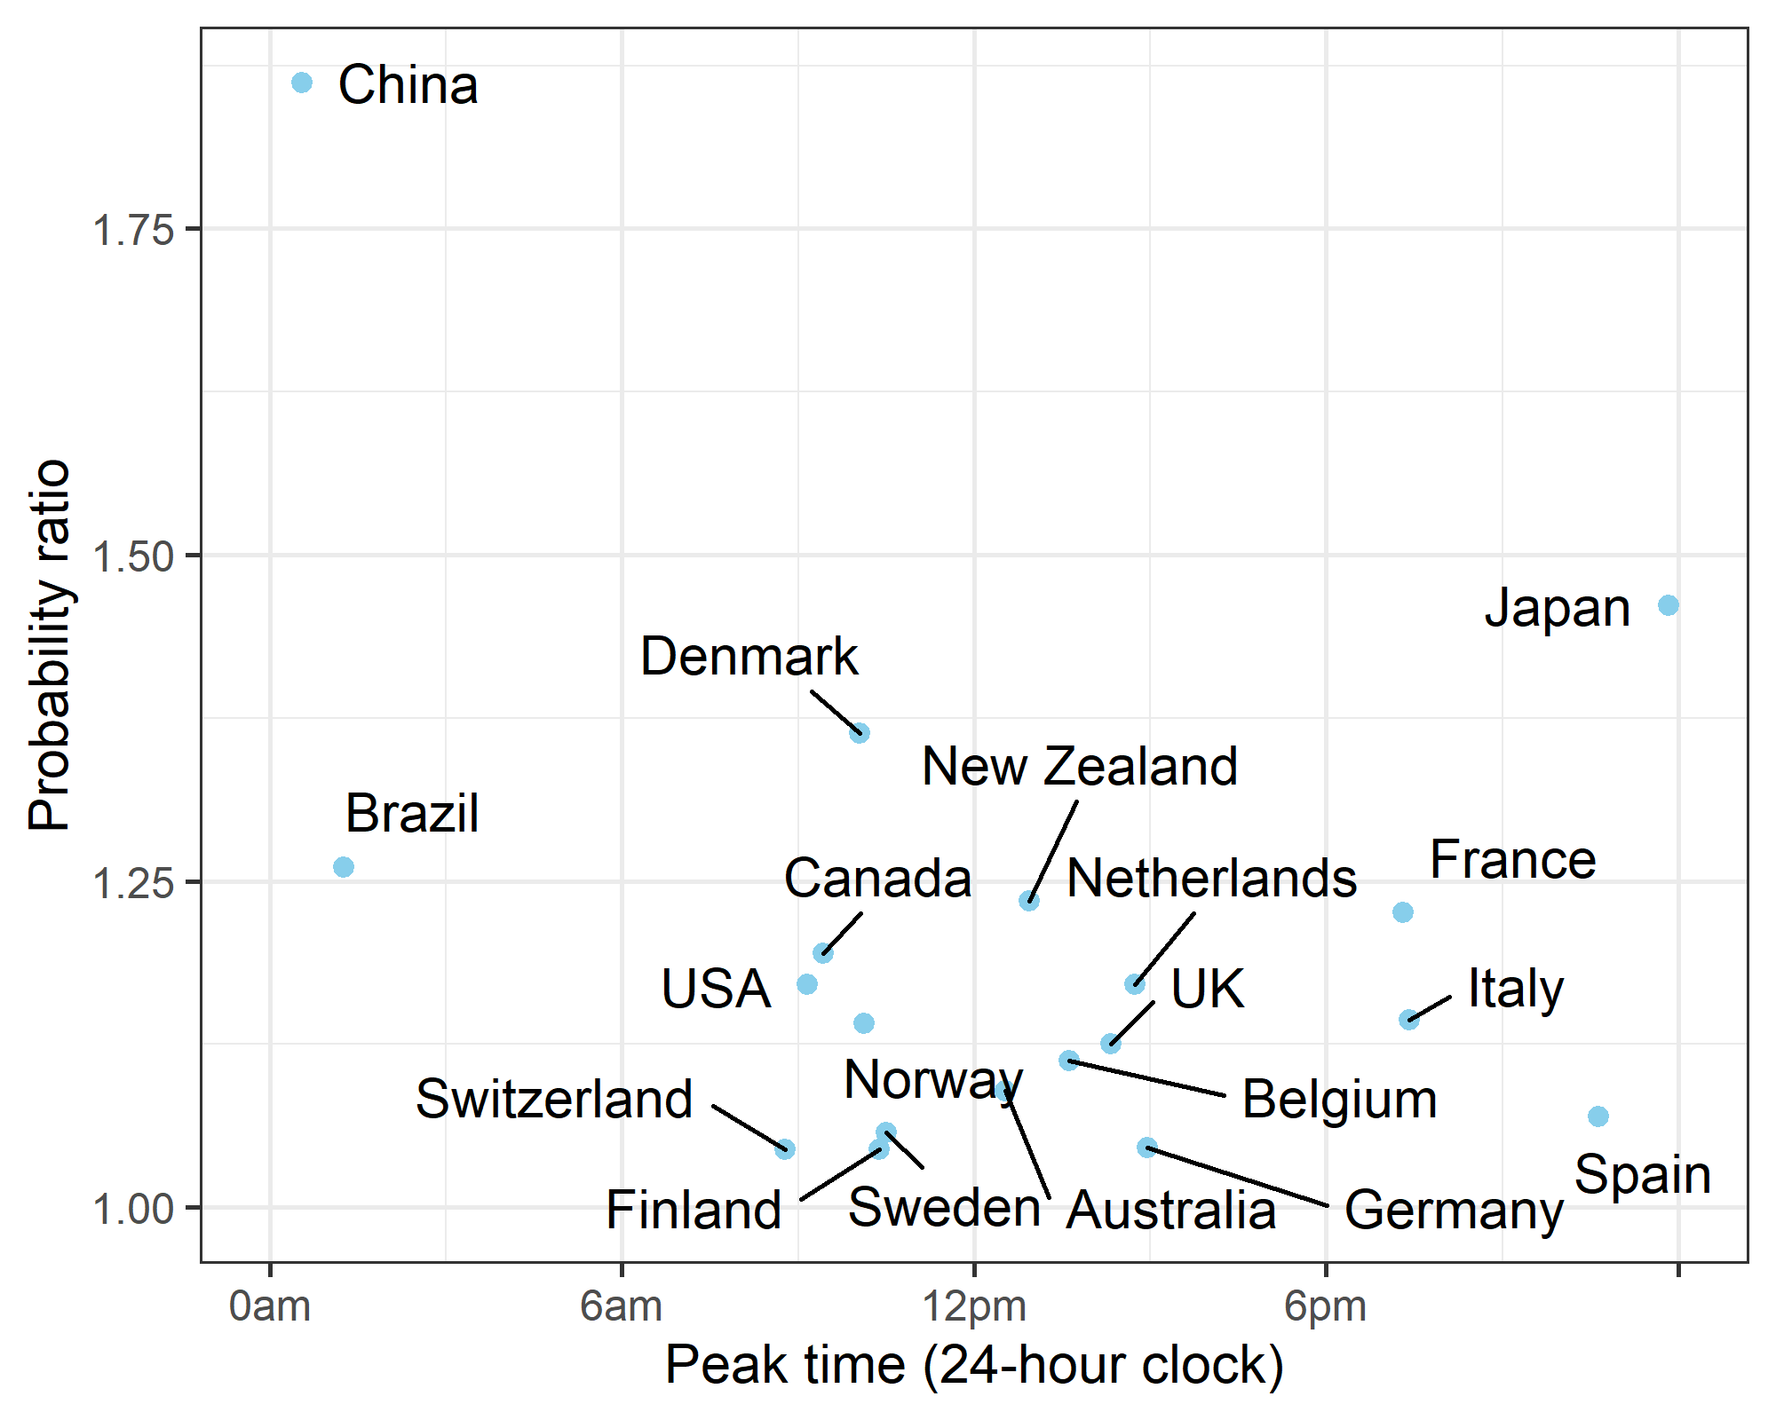

The R-squared of the model is 89%.

### Table of peak time and height for submissions

The table below gives the same information as the above plot. The rows are ordered by the probability ratio.

|  |  |  |  |
| --- | --- | --- | --- |
| country | Peak hour | Probability ratio | 95% CI |
| China | [0-1) | 1.86 | 1.79, 1.94 |
| Japan | [23-0) | 1.46 | 1.36, 1.57 |
| Denmark | [10-11) | 1.37 | 1.27, 1.47 |
| Brazil | [1-2) | 1.27 | 1.14, 1.42 |
| New Zealand | [12-13) | 1.25 | 1.12, 1.39 |
| France | [19-20) | 1.23 | 1.14, 1.33 |
| Canada | [9-10) | 1.20 | 1.13, 1.27 |
| Netherlands | [14-15) | 1.17 | 1.12, 1.23 |
| USA | [9-10) | 1.17 | 1.12, 1.23 |
| Norway | [10-11) | 1.15 | 1.05, 1.26 |
| Italy | [19-20) | 1.15 | 1.06, 1.25 |
| Belgium | [13-14) | 1.15 | 1.03, 1.29 |
| UK | [14-15) | 1.13 | 1.09, 1.16 |
| Australia | [12-13) | 1.09 | 1.05, 1.15 |
| Finland | [10-11) | 1.09 | 1.02, 1.20 |
| Spain | [22-23) | 1.09 | 1.02, 1.19 |
| Switzerland | [8-9) | 1.08 | 1.01, 1.19 |
| Sweden | [10-11) | 1.07 | 1.02, 1.15 |
| Germany | [14-15) | 1.07 | 1.01, 1.14 |

Submissions from China were 86% higher than the average during the hours of midnight to just before 1am. Germany had the smallest increase in submissions at just 7% higher than the average from 10am to just before 11am.

## Difference in journal submissions (late nights and early mornings)

The plot below shows the predicted means for each hour of the day for the two journals. This combines the overall estimates for each hour with the smooth sinusoid used to model the differences between the two journals.

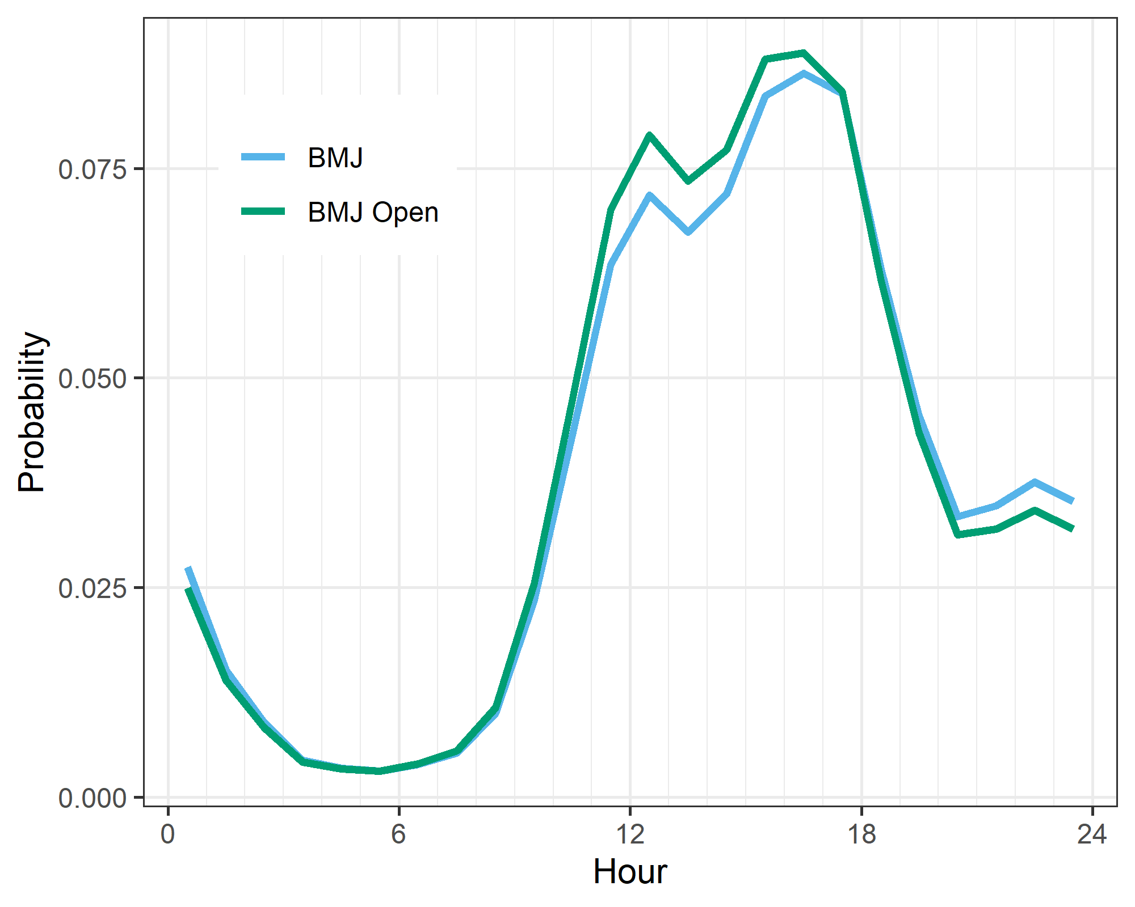

As the plot shows, there was little difference in the timing of reviews between the two journals. There were slightly more reviews for the BMJ Open around midday.

## Peak time for reviews by country

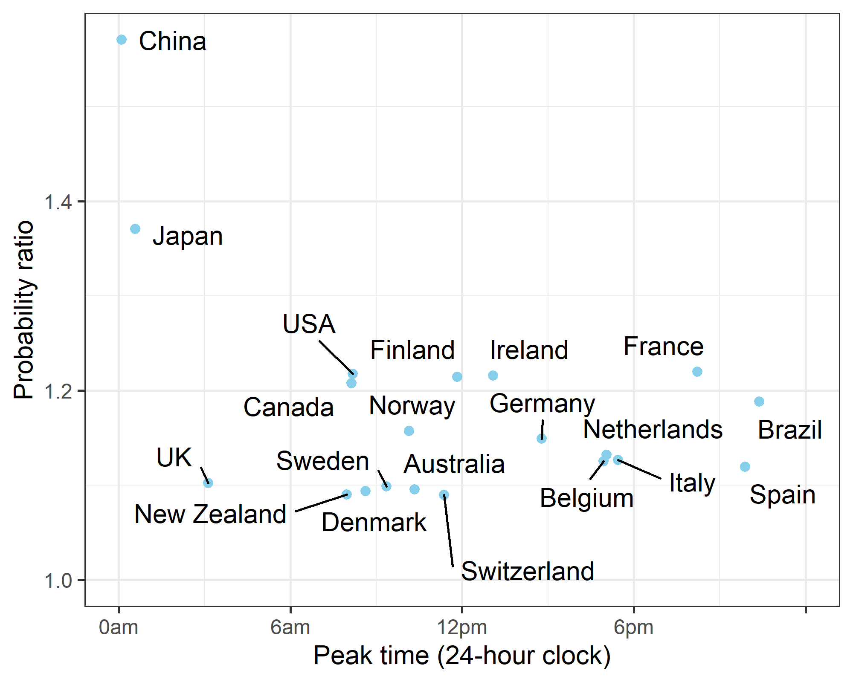

The R-squared of the model is 85%.

### Table of peak time and height for reviews

The table below gives the same information as the above plot. The rows are ordered by the probability ratio.

|  |  |  |  |
| --- | --- | --- | --- |
| country | Peak hour | Probability ratio | 95% CI |
| China | [0-1) | 1.57 | 1.46, 1.68 |
| Japan | [0-1) | 1.37 | 1.27, 1.47 |
| France | [20-21) | 1.22 | 1.13, 1.31 |
| USA | [8-9) | 1.22 | 1.18, 1.25 |
| Ireland | [13-14) | 1.22 | 1.11, 1.33 |
| Finland | [11-12) | 1.21 | 1.10, 1.33 |
| Canada | [8-9) | 1.21 | 1.15, 1.26 |
| Brazil | [22-23) | 1.19 | 1.09, 1.30 |
| Norway | [10-11) | 1.16 | 1.07, 1.26 |
| Germany | [14-15) | 1.15 | 1.08, 1.22 |
| Netherlands | [17-18) | 1.13 | 1.07, 1.20 |
| Italy | [17-18) | 1.13 | 1.07, 1.19 |
| Belgium | [16-17) | 1.13 | 1.03, 1.25 |
| Spain | [21-22) | 1.12 | 1.04, 1.20 |
| UK | [3-4) | 1.10 | 1.08, 1.13 |
| Sweden | [9-10) | 1.10 | 1.03, 1.18 |
| Australia | [10-11) | 1.10 | 1.05, 1.14 |
| Denmark | [8-9) | 1.09 | 1.03, 1.18 |
| New Zealand | [7-8) | 1.09 | 1.02, 1.18 |
| Switzerland | [11-12) | 1.09 | 1.02, 1.18 |

China has the highest increase in reviews, with an average 57% higher during the hours of midnight to just before 1am. Switzerland had the smallest increase in reviews at just 9% higher than the average from 11am to just before midday.

## Difference in journal reviews (late nights and early mornings)

The plot below shows the predicted means for each hour of the day for the two journals. This combines the overall estimates for each hour with the smooth sinusoid used to model the differences between the two journals.

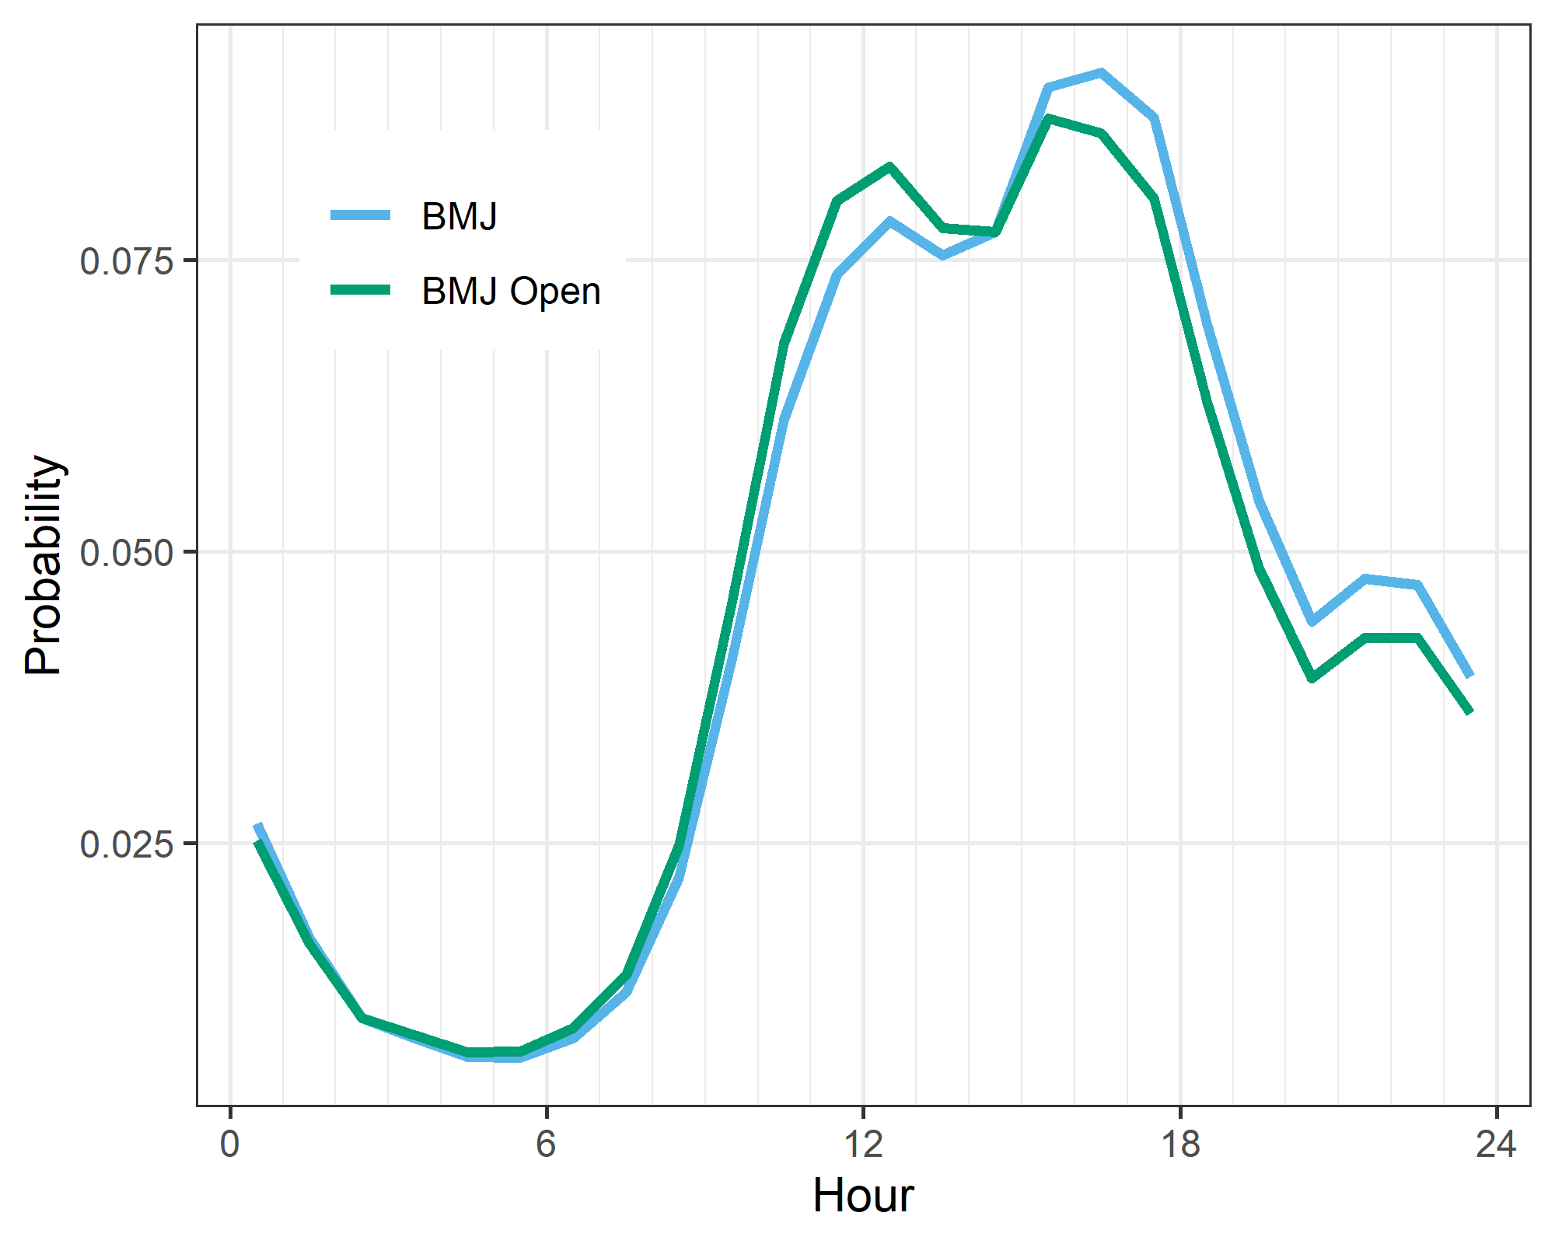

As the plot shows, there was little difference in the timing of reviews between the two journals. There were slightly more reviews for the BMJ around 6pm.

# Summary plot of reviews and submissions by hour of day

The plot shows the percent of submissions and reviews by hour, split by each journal.

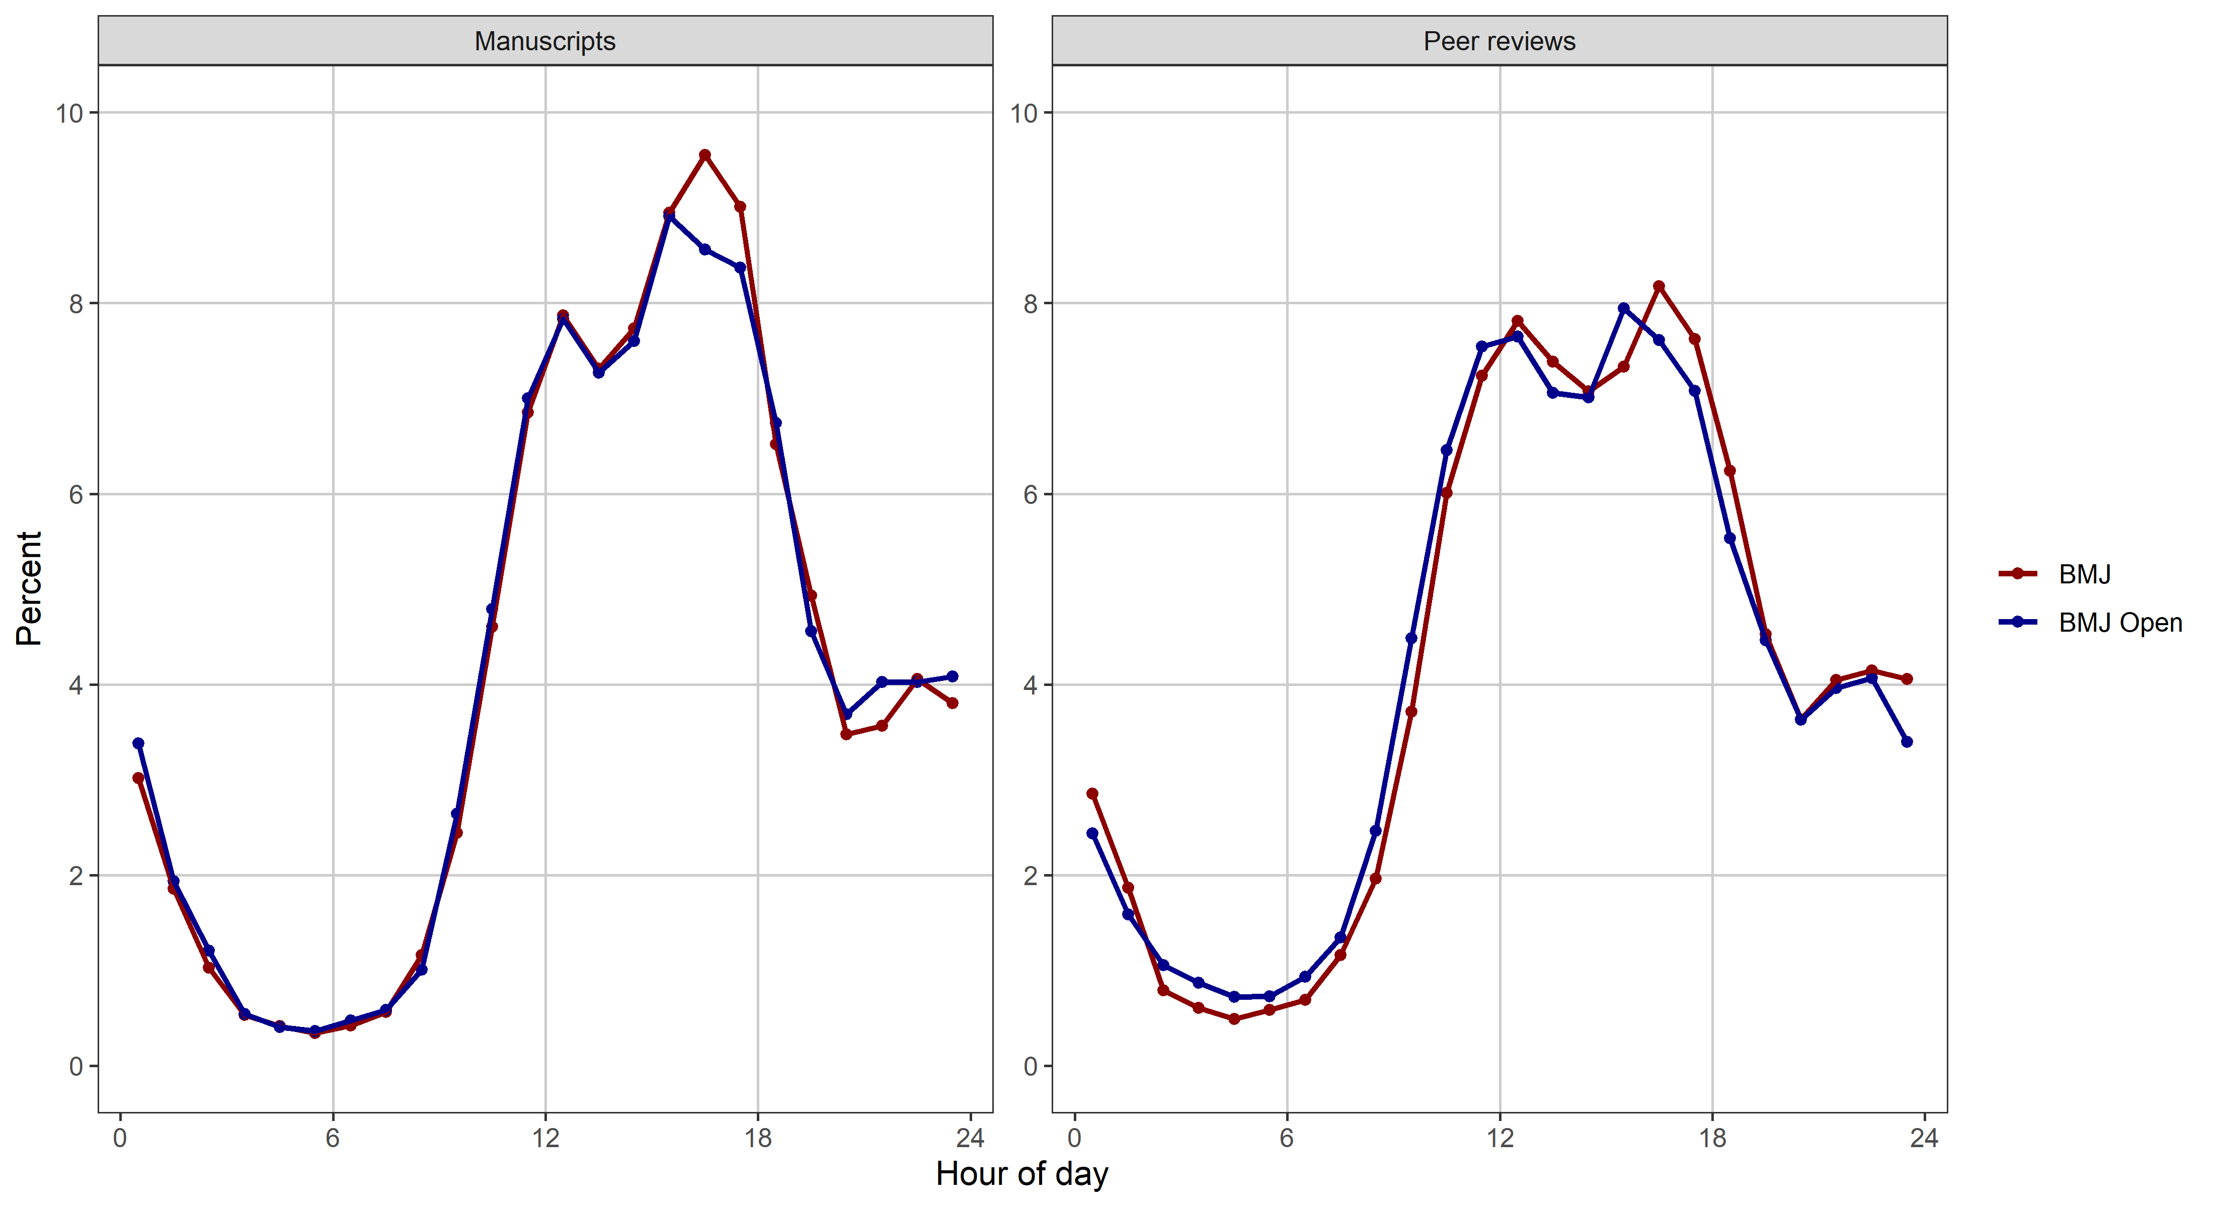

# Summary plot of country-specific probabilities

### Summary plot of weekend estimates

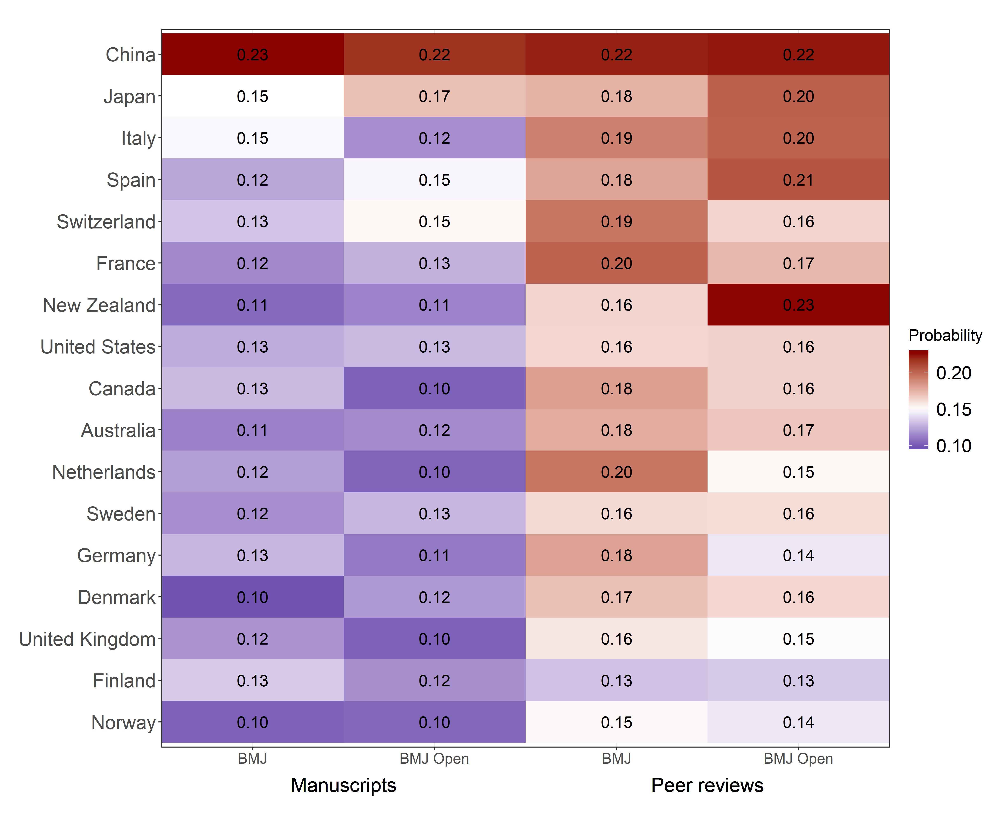

The numbers in the plot are the mean probabilities of submitting on weekends.

The rows in the plot are ordered using the average probability across the four columns.

### Summary plot of holiday estimates

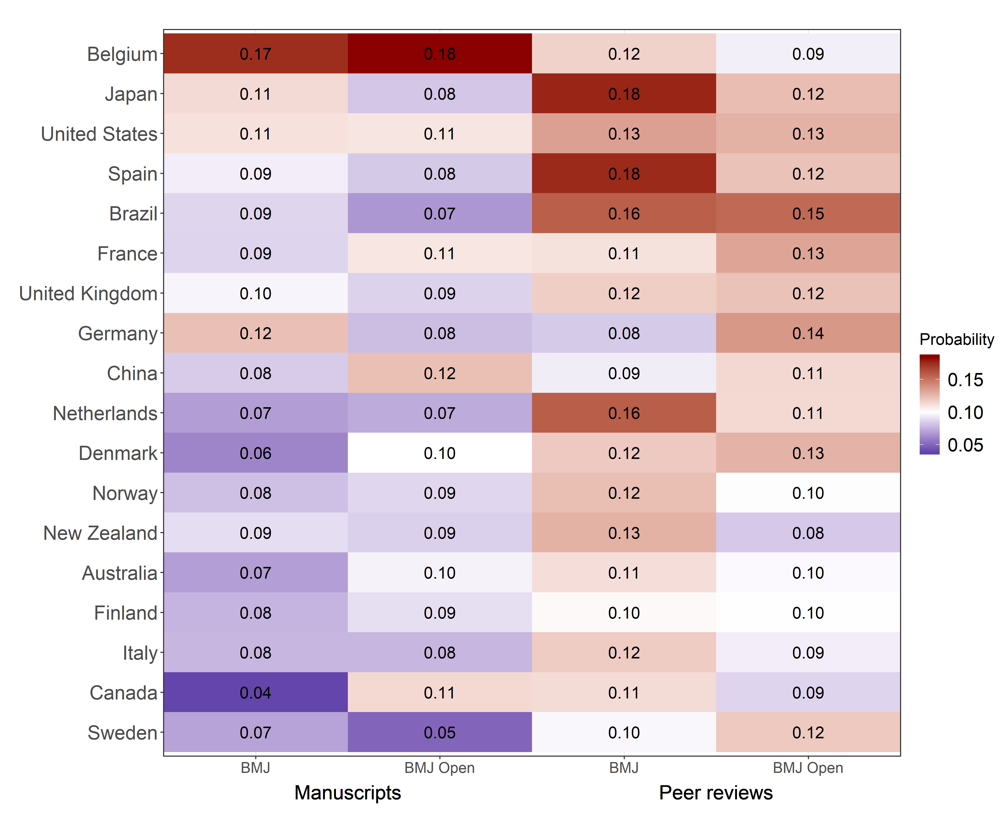

The numbers in the plot are the mean probabilities of submitting on holidays relative to other days in the same week.

The rows in the plot are ordered using the average probability across the four columns.

# Summary plot of country-specific probability ranks

The plot below summarises the twelve models using the countries’ estimated probabilities. It shows each country’s relative rank with 0 (blue) meaning they were the lowest ranked country, 1 (red) the highest, and 0.5 (white) in the middle. We do not show countries with small numbers. The countries are ordered based on their average probability. The plot only shows the mean rank and not the variability in rank.

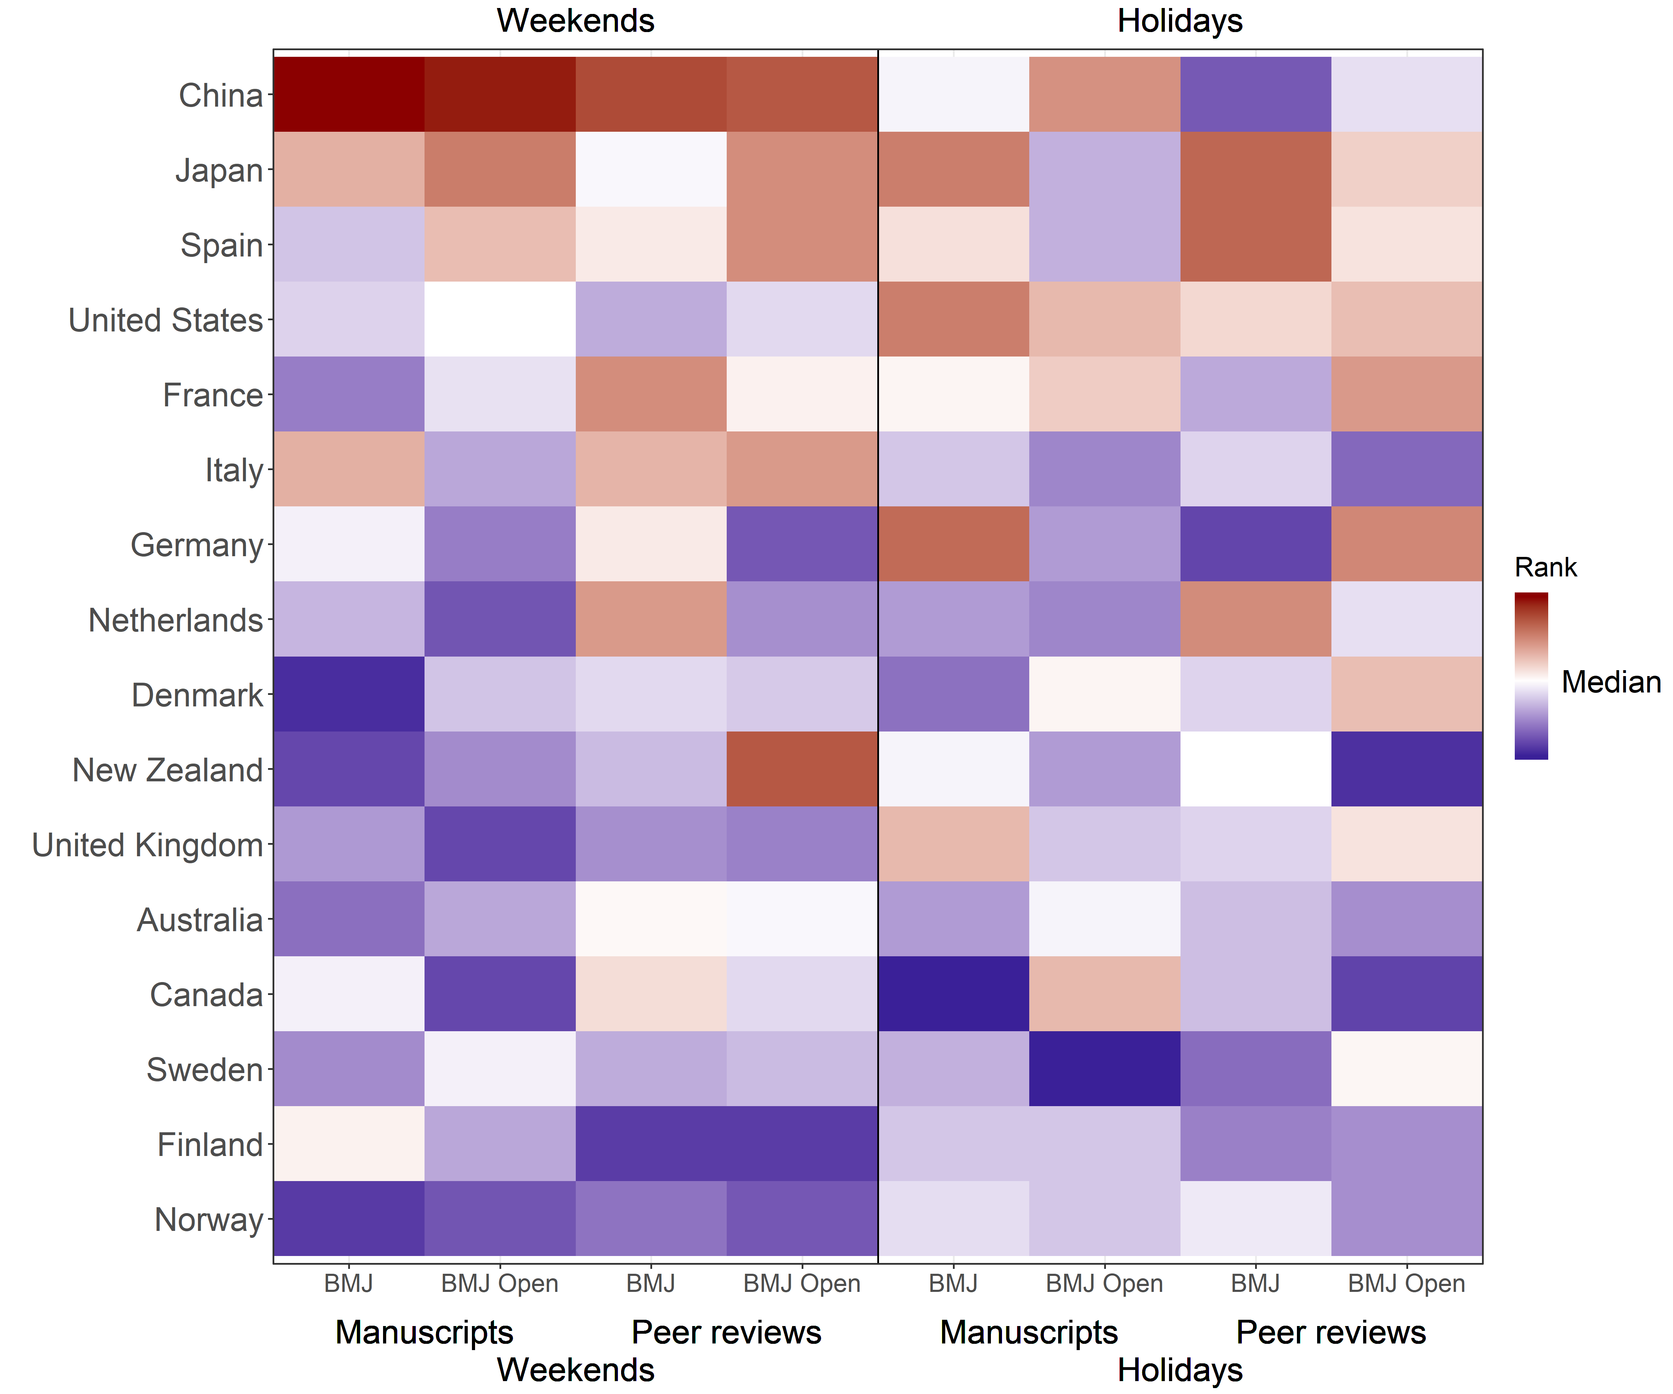

China often had the highest probability of any country for submissions and reviews, but were on or below the median rank on holidays. Japan also had relatively high probabilities.

Three Scandinavian countries (Norway, Finland and Sweden) had some of the lowest probabilities. Denmark was also relatively low.

Three mediterranean countries (Spain, Italy and France) have relatively high probabilties. Many workplaces in Spain have a siesta during the day and working in the evenings is relatively normal.

# Summary plot of overall probabilities, means and 95% credible intervals

The plot below shows the overall probabilities of reviews and submissions on weekends and holidays. These are the overall averages across all countries together with the 95% credible intervals.

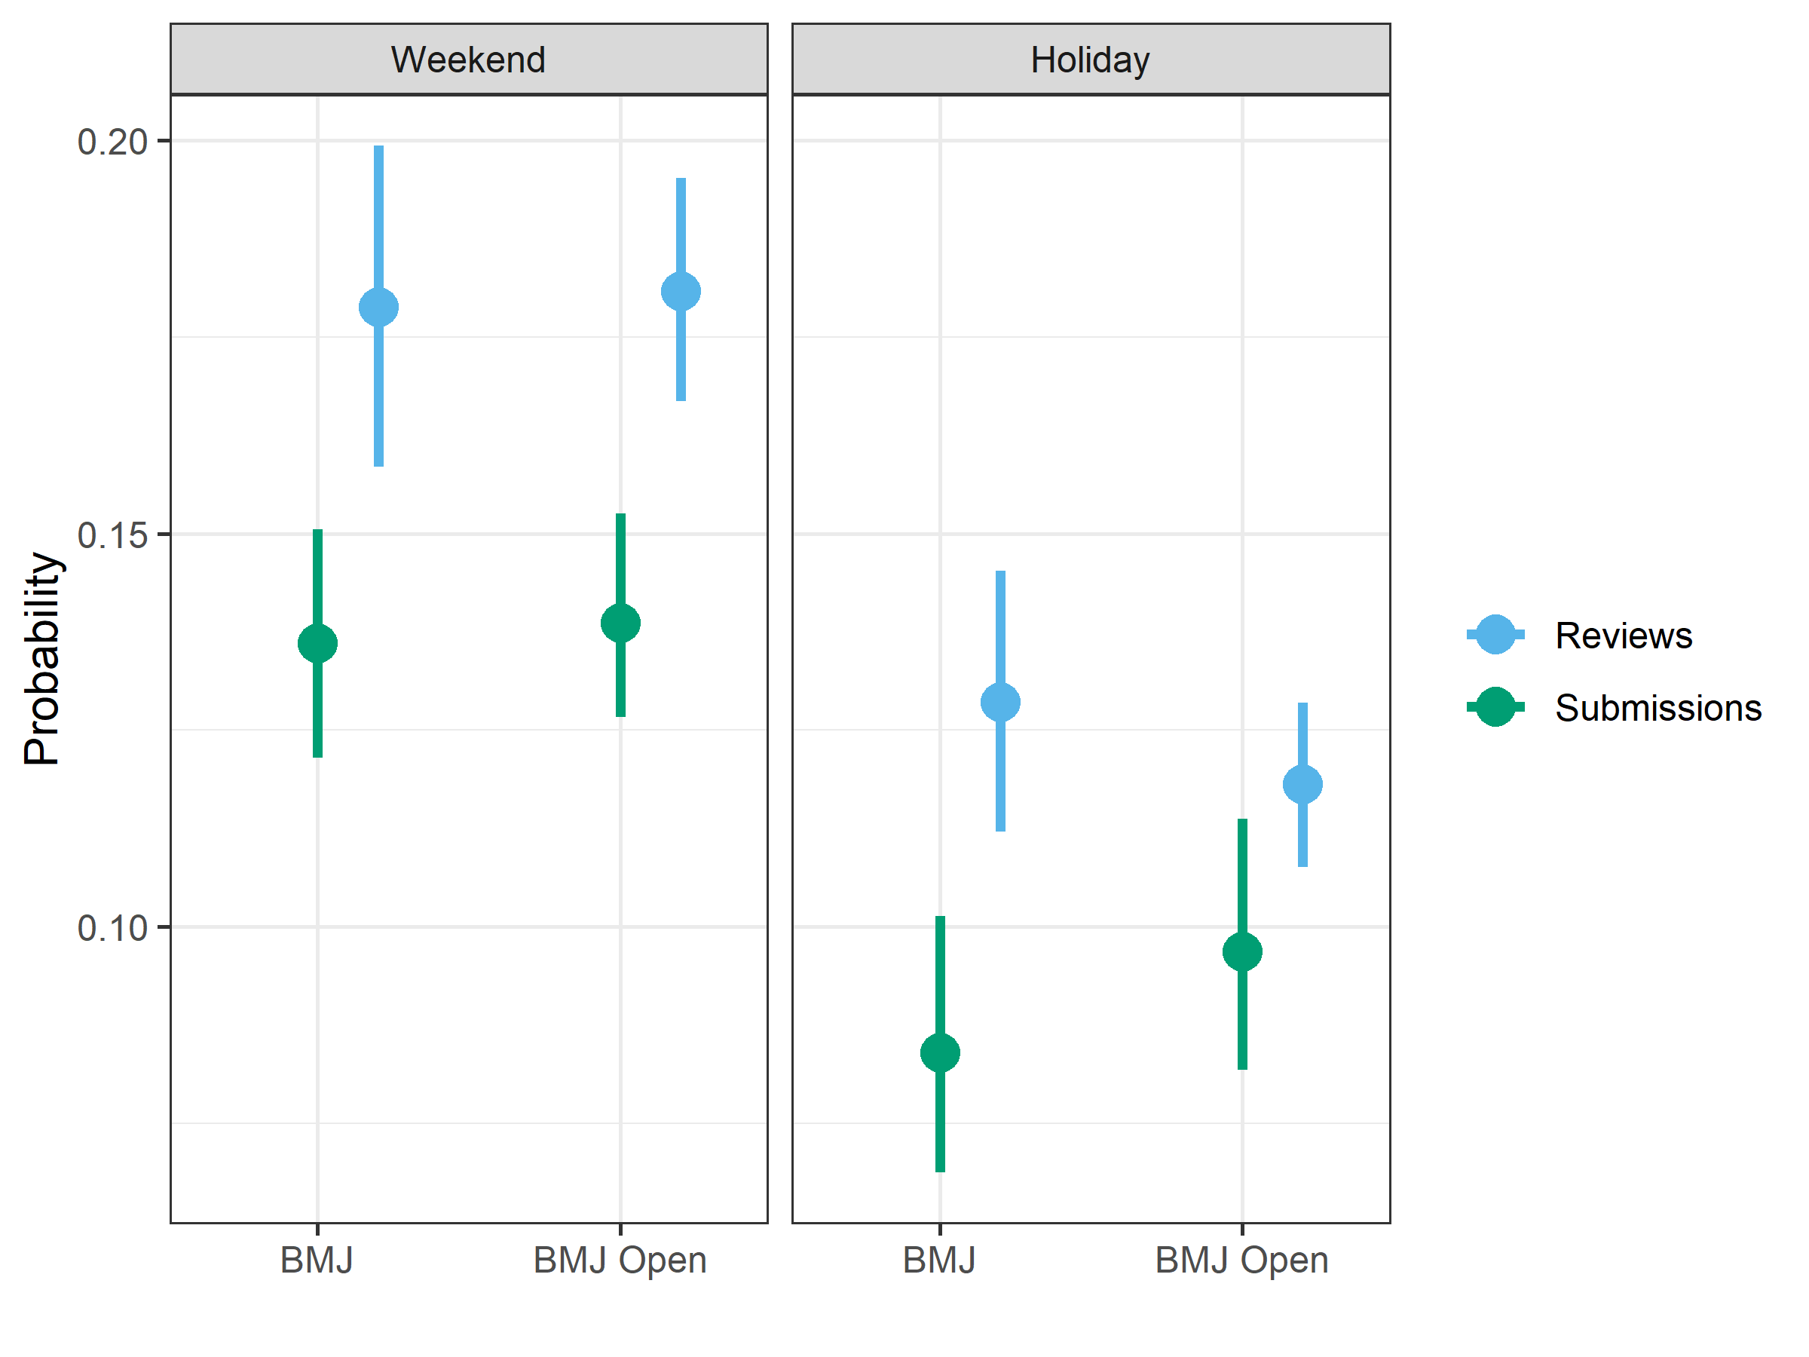

There was a higher probability of reviews on the weekend compared with submissions.

The were no big differences between the two journals.

## Table of overall probabilities

The table below shows the same information as the previous plot (CI = 95% credible interval).

|  |  |  |  |  |
| --- | --- | --- | --- | --- |
| Outcome | Type | Journal | Mean | CI |
| weekend | Submissions | BMJ | 0.136 | 0.12 to 0.15 |
| weekend | Submissions | BMJ Open | 0.139 | 0.13 to 0.15 |
| weekend | Reviews | BMJ | 0.179 | 0.16 to 0.2 |
| weekend | Reviews | BMJ Open | 0.181 | 0.17 to 0.2 |
| holiday | Submissions | BMJ | 0.084 | 0.07 to 0.1 |
| holiday | Submissions | BMJ Open | 0.097 | 0.08 to 0.11 |
| holiday | Reviews | BMJ | 0.129 | 0.11 to 0.15 |
| holiday | Reviews | BMJ Open | 0.118 | 0.11 to 0.13 |

## Summary table of changes over time

This table summarises the changes over time.

### Probability ratios

|  |  |  |  |
| --- | --- | --- | --- |
| outcome | journal | data | Mean CI |
| weekend | BMJ | Submission | 0.99 (0.91, 1.07) |
| weekend | BMJ Open | Submission | 1.01 (0.93, 1.09) |
| weekend | BMJ | Reviews | 1.01 (0.92, 1.10) |
| weekend | BMJ Open | Reviews | 1.02 (0.95, 1.11) |
| holiday | BMJ | submission | 1.00 (0.98, 1.02) |
| holiday | BMJ Open | submission | 1.00 (0.98, 1.02) |
| holiday | BMJ | reviewer | 1.00 (0.98, 1.02) |
| holiday | BMJ Open | reviewer | 1.00 (0.99, 1.01) |

### Probability differences (absolute)

|  |  |  |  |
| --- | --- | --- | --- |
| outcome | journal | data | Mean CI |
| weekend | BMJ | Submission | -0.002 (-0.013, 0.009) |
| weekend | BMJ Open | Submission | 0.001 (-0.010, 0.012) |
| weekend | BMJ | Reviews | 0.002 (-0.013, 0.018) |
| weekend | BMJ Open | Reviews | 0.004 (-0.009, 0.018) |
| holiday | BMJ | submission | -0.000 (-0.003, 0.002) |
| holiday | BMJ Open | submission | -0.000 (-0.003, 0.002) |
| holiday | BMJ | reviewer | -0.000 (-0.003, 0.003) |
| holiday | BMJ Open | reviewer | 0.000 (-0.002, 0.002) |

### Probability differences (absolute percents)

This is the same table as above, but on a percentage scale.

|  |  |  |  |
| --- | --- | --- | --- |
| outcome | journal | data | Mean CI |
| weekend | BMJ | Submission | -0.2 (-1.3, 0.9) |
| weekend | BMJ Open | Submission | 0.1 (-1.0, 1.2) |
| weekend | BMJ | Reviews | 0.2 (-1.3, 1.8) |
| weekend | BMJ Open | Reviews | 0.4 (-0.9, 1.8) |
| holiday | BMJ | submission | -0.0 (-0.3, 0.2) |
| holiday | BMJ Open | submission | -0.0 (-0.3, 0.2) |
| holiday | BMJ | reviewer | -0.0 (-0.3, 0.3) |
| holiday | BMJ Open | reviewer | 0.0 (-0.2, 0.2) |

# Four by four panel for forest plots

## Weekends

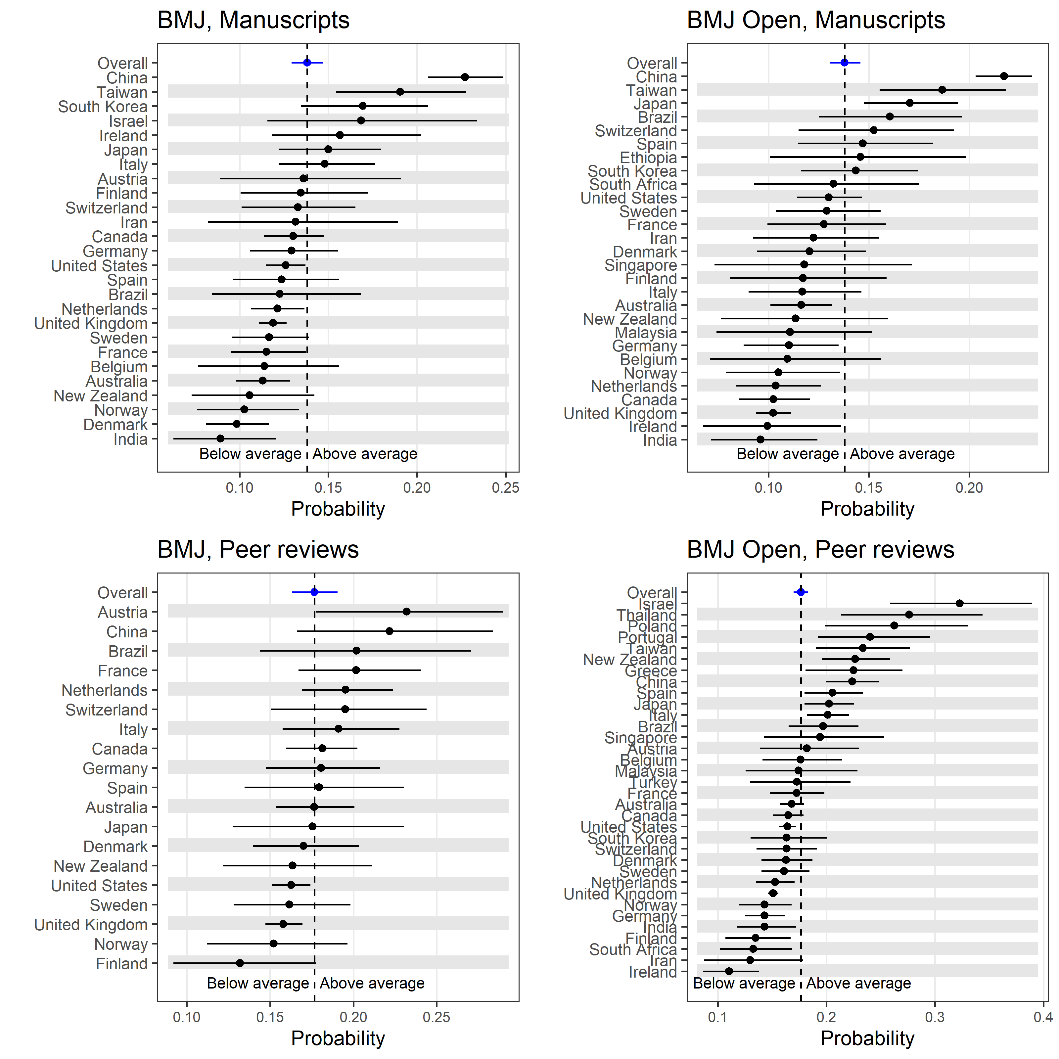

## Holidays

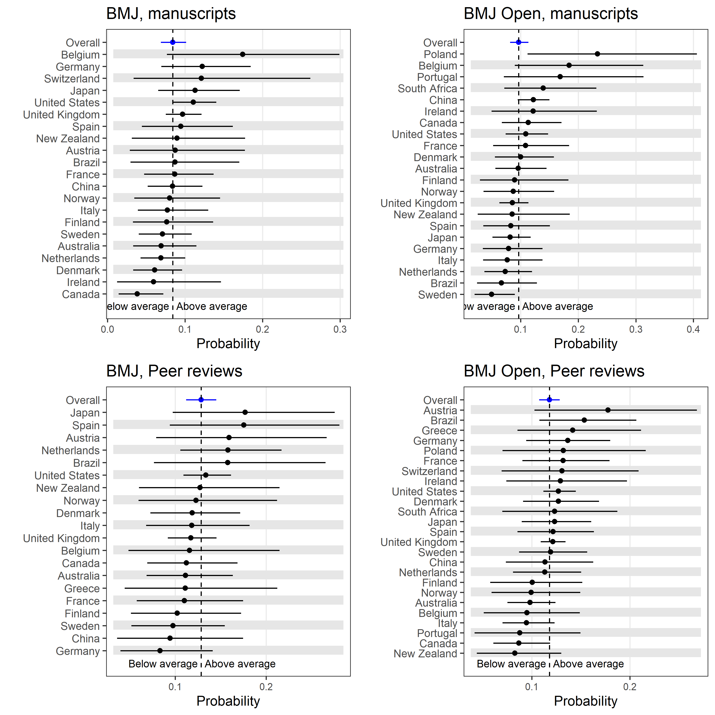

## Double panel plot for journal

Weekend and holiday manuscript submissions to *The BMJ*.

